The Applications of 3D Printing In Theatre
By: Tyler DiGregorio Aubin
Faculty Advisor: Szu-Feng Chen
Fall 2021

Table of Contents
Intro
Materials and Filaments
Printers
Software
Uses in Theatre
Examples of Current Use in Theatre
How to Utilize It In Theatre
Resin Printing
Printing for UNH THDA She Kills Monsters
Wood PLA Filament
3D Printing Resources
Conclusion
Image Gallery

Intro
I am someone who is incredibly interested in technology. This interest has driven my education in theatre technology and I love when I can bring two of my interests together. Even before this research, I had a deep interest in 3D printing through my participation in FIRST robotics and when the opportunity arose to combine my interest in theatre and 3D printing I was ecstatic. This interest started as an INCO class I did with my advisor and continued to develop as a topic I could present at both Naked Arts, the creative art division of the Undergraduate Research Conference at UNH, and for my capstone project. The purpose of this research is to explore the applications of 3D printing in theatre. The goal is to learn about the different printers, materials, and software to determine the best way this technology can be utilized at different levels and areas of theatre. To accomplish this I have found online articles that both directly relate to current 3D printing in theatre and the 3D printing industry. I have visited local 3D printing shops and contacted theatrical technical directors to find out what 3D printing technologies they have used in their work as well as creating my own prints for theatrical use. I set out with the goal to use this research to learn more about the connection between my two interests of theatre technology and 3D printing and to apply what I learned to department productions.

Materials and Filaments
One of the most important aspects of 3D printing is choosing the right material for the applications you are trying to use it for. Different printing materials will have different properties such as ease of print, cost, durability, finish, and other features such as Ultraviolet reactants or flexible prints. The reason that this is being covered first is that certain types of printers are limited in what materials they can print in, so you should have an idea of what material you need so you can find a printer that can effectively print in that material.
Some examples of different 3D printing materials are Polylactic Acid (PLA), Acrylonitrile Butadiene Styrene (ABS), (Polyethylene terephthalate glycol (PETG ), Nylon, Thermoplastic polyurethane (TPU), Polycarbonate (PC), and Resin. All of these materials have different strengths and weaknesses and depending on the application one would be better than another. For example, if you are making a scale model of a set for a theatre production, PLA would be a good choice due to its easy to print characteristics and low cost. However, if you want your final model to have fine details Resin would be a better option as it can capture much more detail on smaller scales, this is a concept that I will explore later in my research. The chart below shows the features of each commonly used material.
Material | Ease of Print | Finish | Toughness | Feature | Price | Quantity
PLA | High | Medium | Low | Cheap | ~$20 | 1 Kg Spool
ABS | Low | Medium | Low to medium | Heat Resistant | ~$20 | 1 Kg Spool
PETG | Medium | Medium | Upper Medium | Stronger than PLA but similar print properties | ~$20 | 1 Kg Spool
Nylon | Low to medium | Low to medium | High | High Impact | ~$30 | 1 Kg Spool
TPU | Low | Low | Incredibly High | (Flexible) | ~$20 | 1 Kg Spool
PC | Low to medium | Medium | High | Easy to post-process | ~$50 | 1 Kg Spool
Another key factor to keep in mind about materials is any toxicity they may produce and whether it has any reactions with either heat or other chemicals. For example, ABS produces toxic fumes when printing so it needs to be printed in an enclosure. ABS also melts when it comes into contact with Isopropyl Alcohol which can be beneficial and detrimental, this allows for the part to be fused and finished easily but it also means you have to be careful that the printed ABS part is not accidentally exposed to the Isopropyl Alcohol or it could ruin the finish or integrity of the print.

Printers
The choice of printer material will have an impact on which printer is chosen. Some printers are better at printing certain types of materials that can only be printed by specialized printers. When choosing the right printer for your application some of the factors you have to keep in mind are price, ease of use, bed size, and material compatibility. There are hundreds of different printers available to purchase and choosing the right one comes down to what you are trying to accomplish with it.
3D printing has had a boom recently and the market has been flooded with different printers. The advantage of this is that there are many printer options for any budget. The disadvantage is there are a lot of printers that are cheap clones of good reliable printers. These printers are also not as user-friendly and unlike some higher end printers on the market take much more experience, tuning, and maintenance to have them running reliably and producing good prints. This does not mean however that budget printers should be avoided entirely, they can still provide quality prints you just have to be willing to put in the time and the effort.
On the other side of the budget, higher quality printers that print more reliably and with less tuning. This does come at a cost however, printers such as one of the most popular ones, the Ultimaker S5, cost considerably more, around five thousand dollars. When budgeting for a printer you need to consider what you get with the extra few grand that you are paying for this printer vs one of the more budget-friendly options. You get something that has come pre-tuned from the manufacturer that has been guaranteed to produce high-quality prints with minimal tuning or effort by the end-user. These printers often also include features such as auto-bed leveling and dual extruders that although they both can be found on cheaper printers require more effort and are not usually as reliable.
Printer | Price | Ease of Use | Printer Type
Ender 3 | ~ $200 | Moderate | FDM
Monoprice Mini Select Pro | ~ $150 | Easy-moderate | FDM
Ultimaker S5 | ~ $6,000 | Easy | FDM
Qidi Tech Xmax | ~ $1,000 | Easy | FDM
Anycubic Photon Mono X | ~ $400 | Difficult | SLAA (Resin)

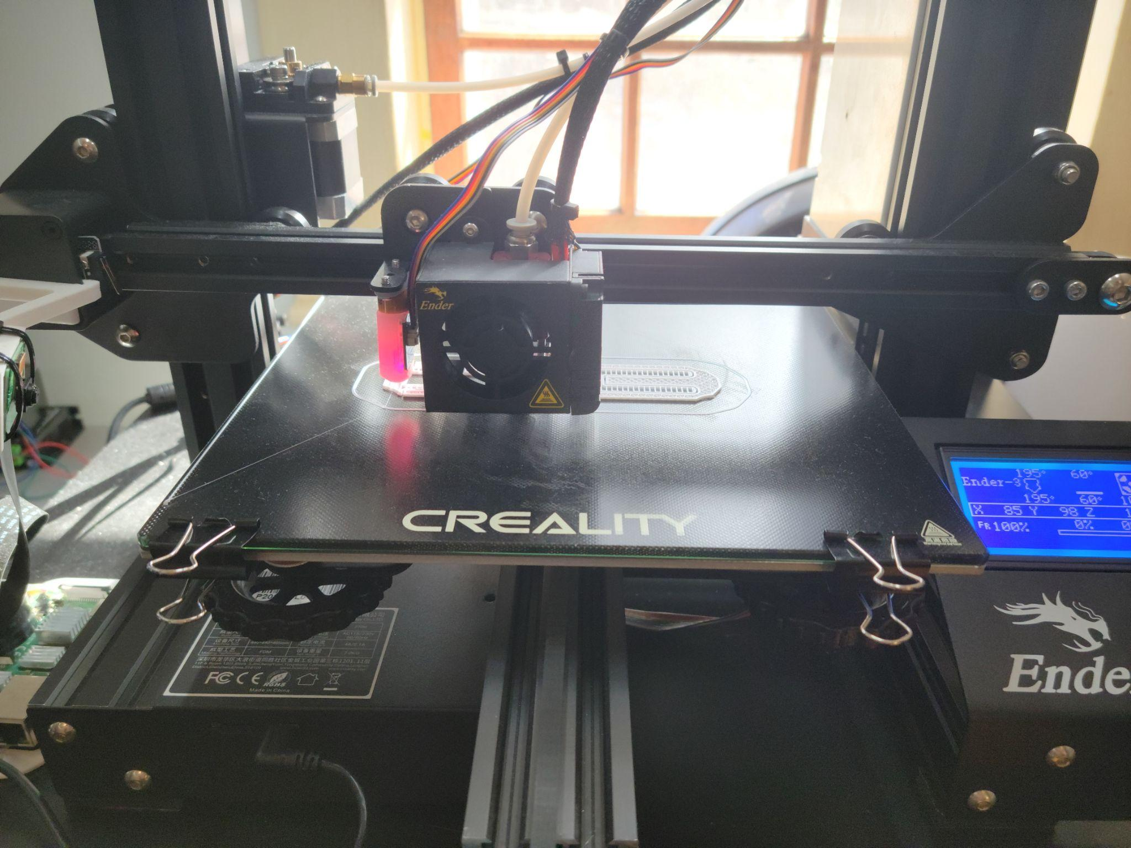
Creality Ender 3 Pro
For larger theatres with bigger productions and budgets and investment into a higher quality is more beneficial. The extra features and reliability that you gain make sense as long as you have the use and the budget for it. Think about it as any other tool that you might have in your costume shop or scene shop. You wouldn't buy the table saw or sewing machine that needs to be tinkered with or taken apart every time you want to rip a piece of sheet goods or make a costume. Buying a higher quality printer would speed up its output and not cause the time to be wasted to just try and get a print created.
On the other hand, if a smaller theatre with no budget for a five thousand dollar printer wants to explore 3D printing's usefulness then a budget one makes more sense. Smaller theatres could be less likely to need the speed and reliability a better printer could offer. For them, the budget ones still can achieve the task they need just with more time and effort, which to theatres with smaller budgets is worth the few grand saved by going for the budget option. Printers like the Ender 3 and Monoprice Mini Pro both are capable of achieving good prints for significantly less.
The printers that have been mentioned so far have all been FDM printers or fused deposition modeling, this means that the printers fuse together layers of material on top of each other to create a model. Resin is currently becoming a more popular type of 3D printing. Resin printers usually use a method called Stereolithography (SLA) or digital light processing (DLP). Instead of fusing together layers of material these printers use light to cure layers of resin to create the model.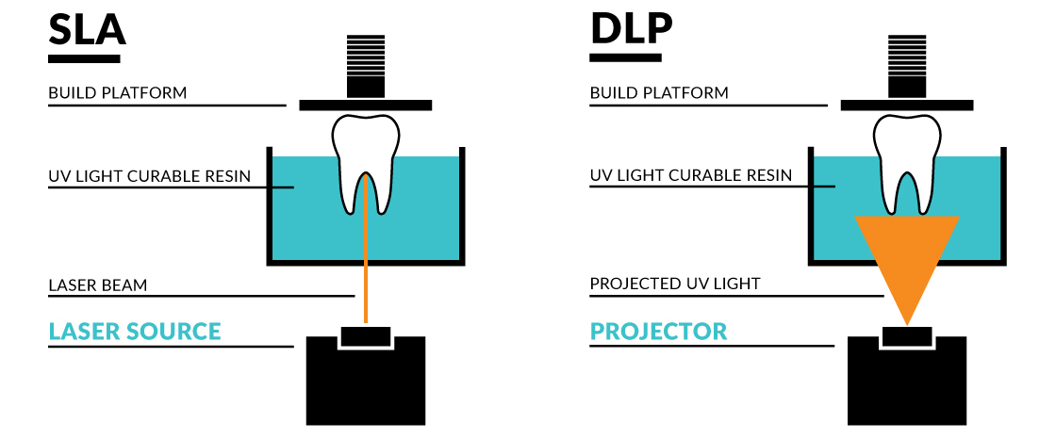
This process created extremely detailed and high-quality prints that cannot be achieved by FDM printers. The disadvantage of these printers is that after the print is complete you need to properly cure it which differs depending on the type of resin used.
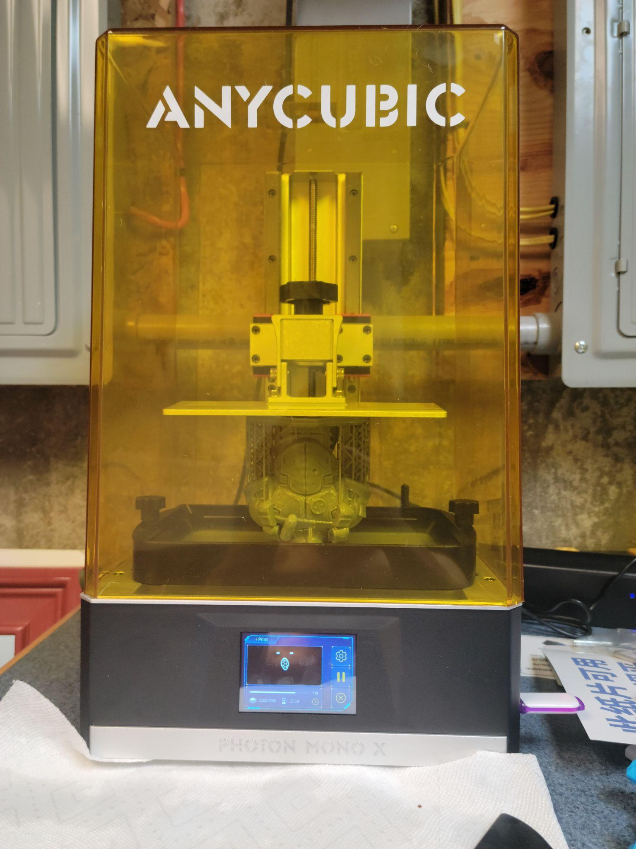
Anycubic Mono X Resin Printer

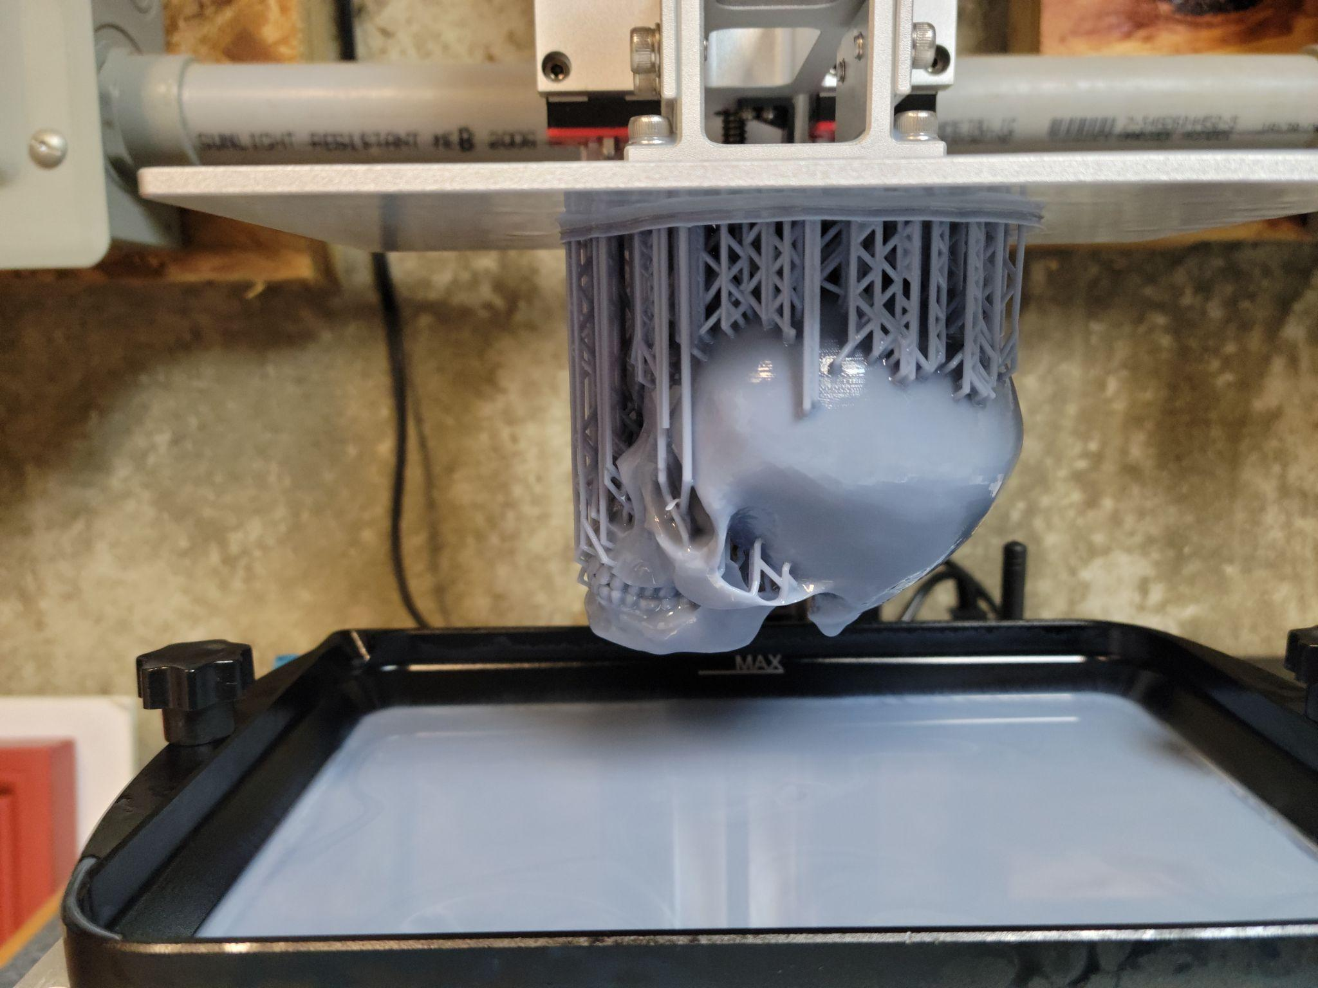
Print From Resin Printer

Software
The next part of this research was into the different software associated with 3D printing. For most cases, there are two different types of software modeling and slicing. This is the program used to create what you want to print, examples of this software are Solidworks, Onshape, and Blender. The next type of software you will need is called a slicer, this is what translates the model you have created into code the printer can understand, this is also where you can adjust settings such as temperature, layer height, and other adjustments that impact how the printer creates the model.
The modeling software that can be used ranges in price and skill level. For the most part, though there is more free modeling software that has many of the features of the paid ones. A good example of this is a program called onshape, it is web-based meaning it will run on almost any computer and it has basic modeling features that for most people are more than enough to create 3D printed models. On the other side, there is software such as Solidworks. Solidworks is a paid software that is seen used in engineering fields as it can simulate loads and identify weak points in structures. While the overall usage of these two softwares is the same, Solidworks has far more advanced features that can be advantages depending on the applications it is being used for such as material simulation and more precise modeling tools.
Slicers are usually included with the printer or can be downloaded for free as they are open source. The reason behind this is that the slicer is what generates the G-code for the printer. The G-code is a set of instructions that the printer uses to make the model. The slicer essentially takes the 3D model that was created in the CAD software and turns it into lines of code that detail how the printer needs to move for each layer. An example of a slicer is Cura. This software is made by the same company that makes the expensive Ultimaker printers but it is free and open-source which means it can be used with many different printers. The slicer also allows you to change print settings. This is extremely important as tuning your printer’s settings will have an enormous impact on the quality and success of your prints. When using a cheaper printer, tuning, and calibration when buying a new filament can mean the difference between a successful print of your model and a failed print.

Uses in Theatre
Currently, 3D printing has been used in many different areas of theatre. I have found examples of props, costumes, and even entire sets being 3D printed. One of the common areas I have seen used in 3D set modeling is where 3D printers are used to create hyper-realistic scale models of sets. Other examples I have seen are different costume pieces like dresses and jewelry such as in the Marvel movies for certain prop pieces such as in Black Panther seen in this article here. I have also visited a 3D printing company called Form 3D in Dover NH; while their primary focus is on metal prototypes for the aerospace industry they have also printed high-quality metal rings for prototypes for jewelry companies. Although this particular company was not theatre-related I hope to visit and talk to more companies and theatres that have utilized 3D printing to expand my knowledge of how they are used.
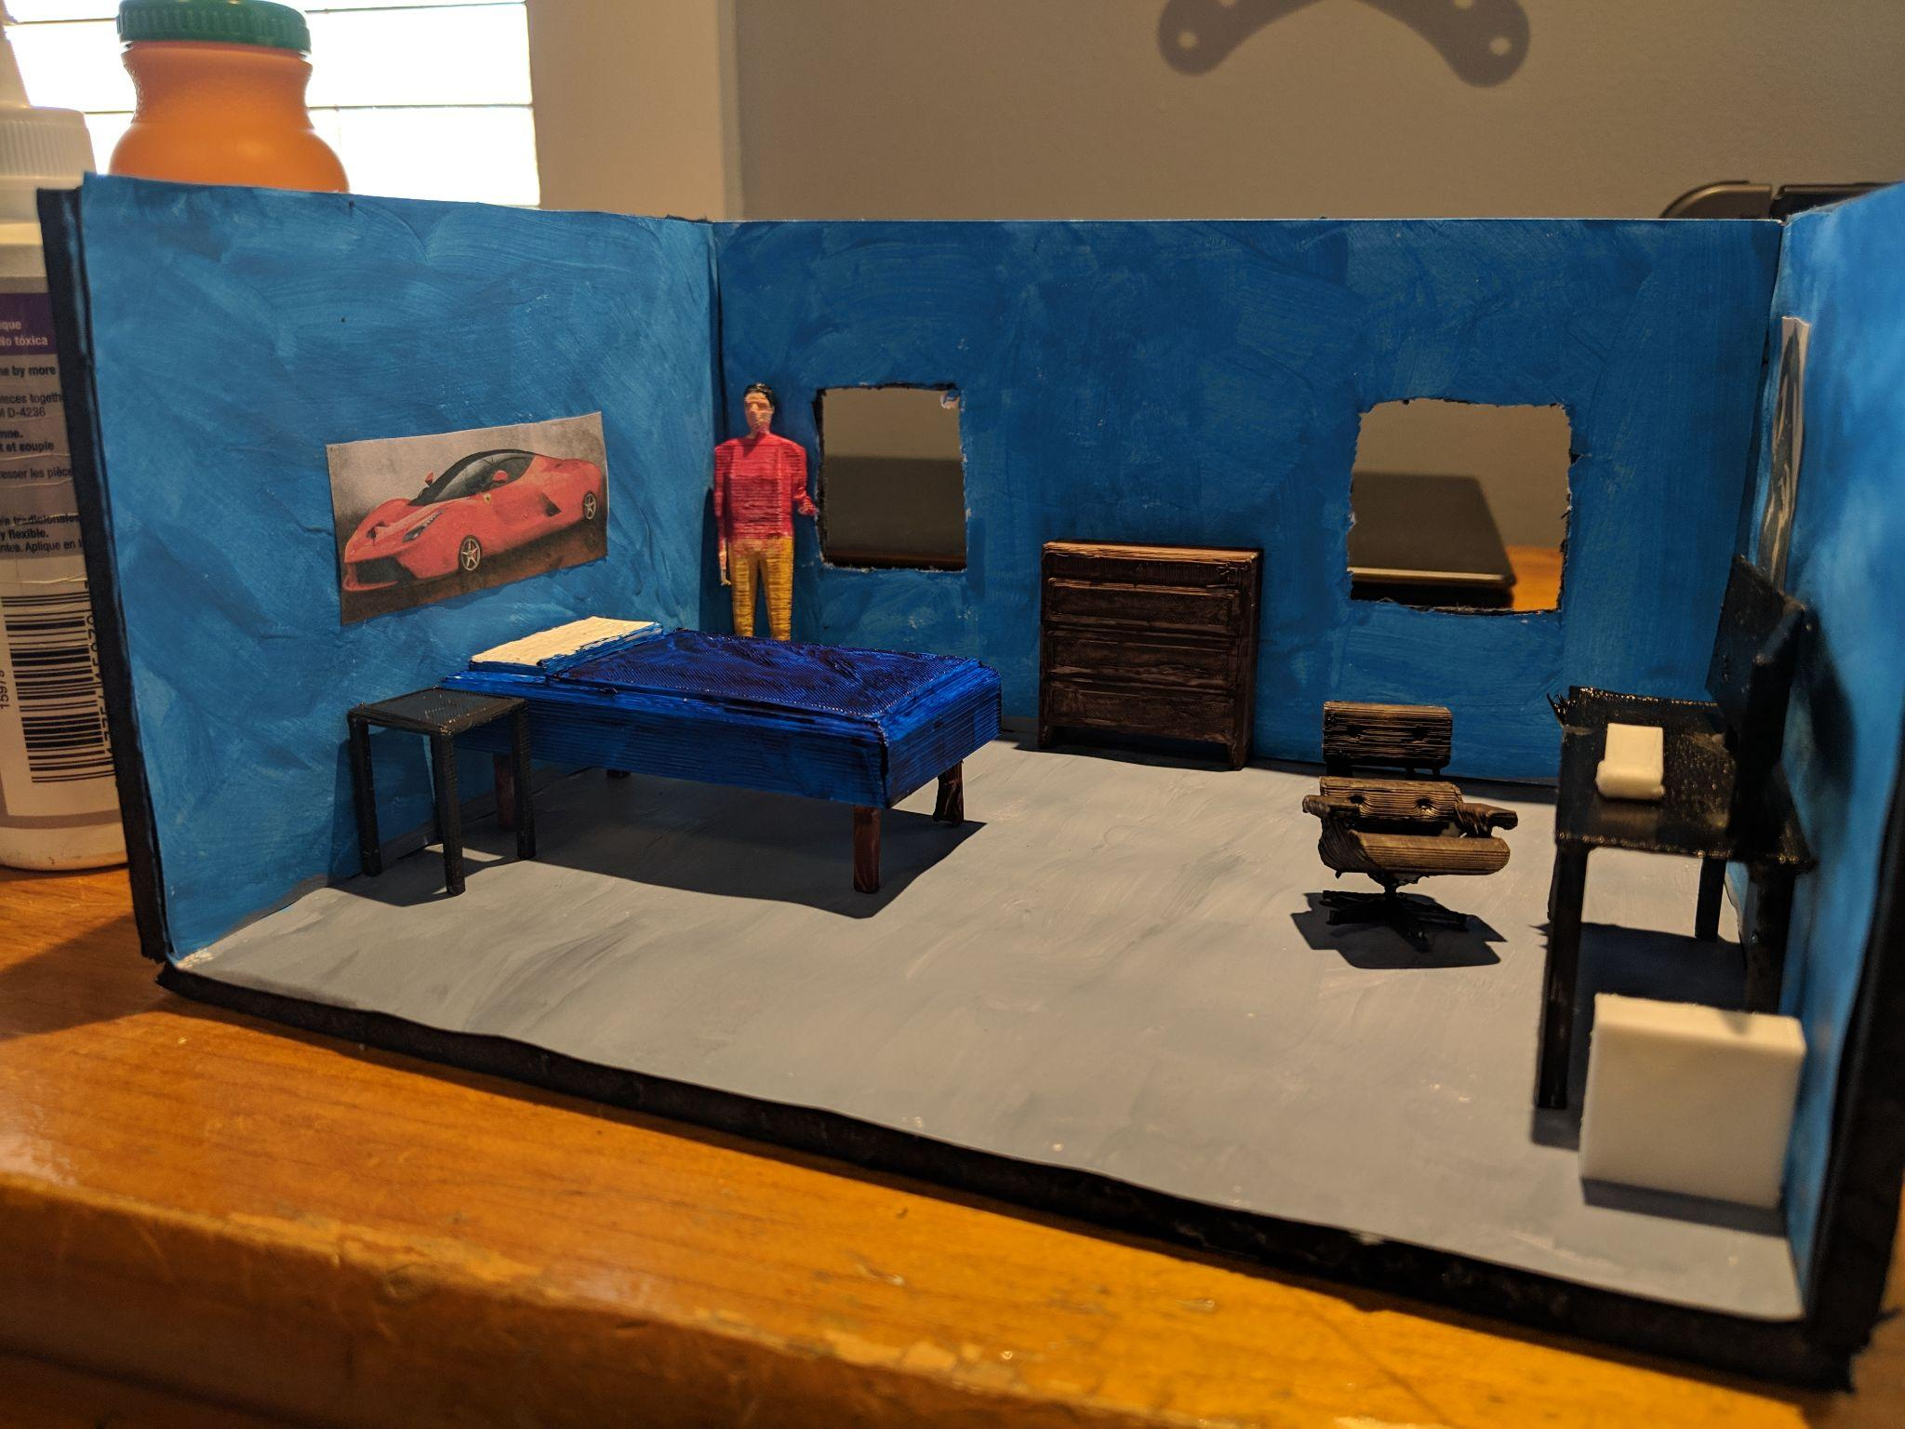
3D Printed Set Models

One of the questions I wanted to answer with this research was trying to figure out what kind of printers would be most conducive to theatre and entertainment. While much of my experience has been with FDM printing there is a wide variety of FDM printers ranging in price and features. In the spring of 2021, I was able to answer some of the questions that I had about this. I wanted to explore how theatres currently used 3D printing, what printers they used, and what their experience was. I also wanted to answer how much a theatre would have to invest in both time and money in order to successfully integrate 3D printing into their workflow. To accomplish this I 3D printed a famous movie prop and I interviewed a technical director at a community theatre to gain first and second hand experience in both of these areas.
For my 3D printed prop, I decided to use a free model of Han Solo's Blaster from Star Wars. I used a model as it had many different sized parts, different textures, and variations in geometry. This was broken up into different parts and I printed all of it on my Ender 3 Pro in white PLA. While I did not print all of the parts in one run I did have to run the printer overnight often and in total would estimate it took over 45 hours of run time for the print to complete. This does not include post-processing. I did encounter a few failed prints but this is nothing out of the ordinary with 3d printing and no matter how advanced you or your printer is you will still need to account for any issues you may have. Even expensive printers can experience failures such as jams and warping because despite their higher price tag they still use the same basic printing principles. After the parts were printed I sanded them with higher grits of sandpaper and rinsed them with water. After they dried I did two coats of primer and then used another two coats of metallic spray paints to achieve the final color and texture.

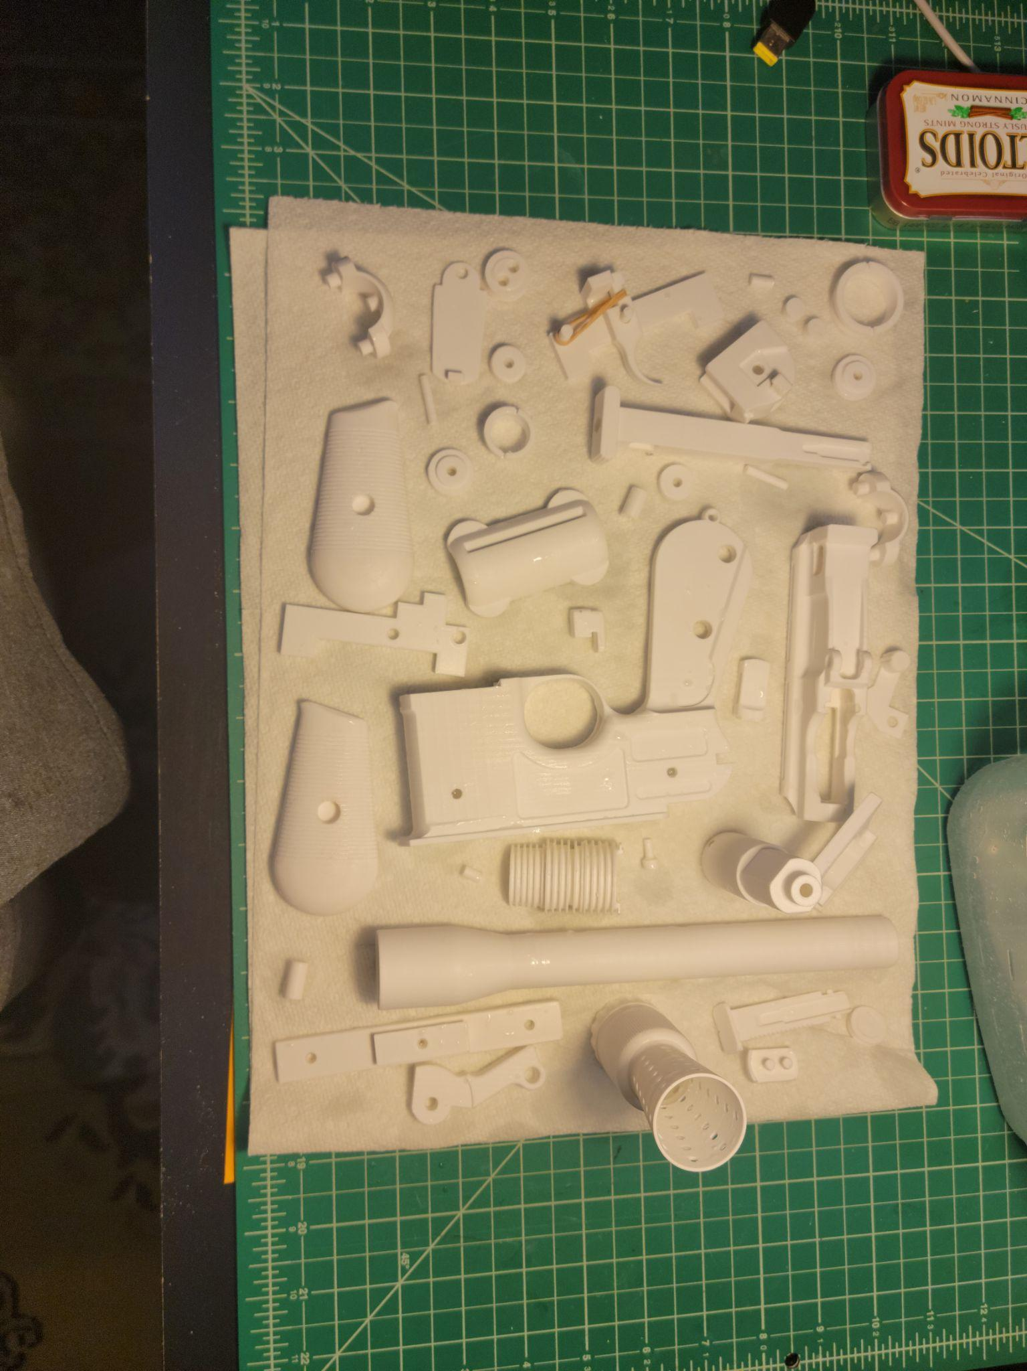
Parts Printed for the Blaster

I also did resin casts using both silicone and 3d printed molds for the grip pieces. I did this because 3D printing can create highly detailed models. It does take a considerable amount of time to create 3D printed parts as most print times are measured in hours. While this is not an issue for creating parts before shows it may pose issues if something breaks. This is where I believe resin casting may provide a solution. Resin casting is a technology that is already widely used in theatrical prop making and it allows the replication of detailed pieces in a matter of minutes. I tried this method using both silicone molds created from the 3D printed parts and also by creating a 3D printed mold to create the cast. Both methods gave good results with both seeming to be viable options. I did have issues with air pockets forming when pouring the resin but I think that is more of an issue of my lack of experience in resin casting than any issue with 3D printing being used with resin casting.
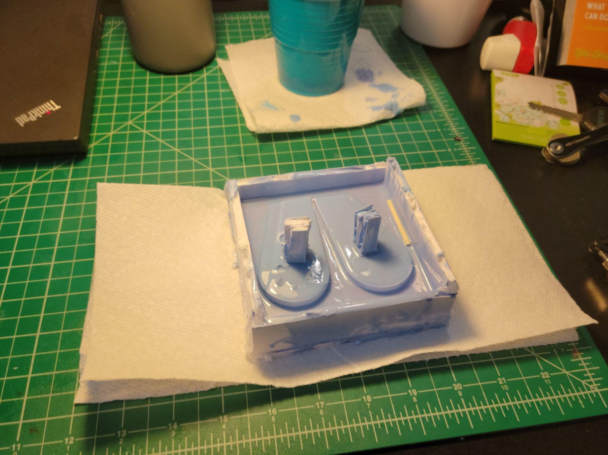
Parts Cast in Silicone
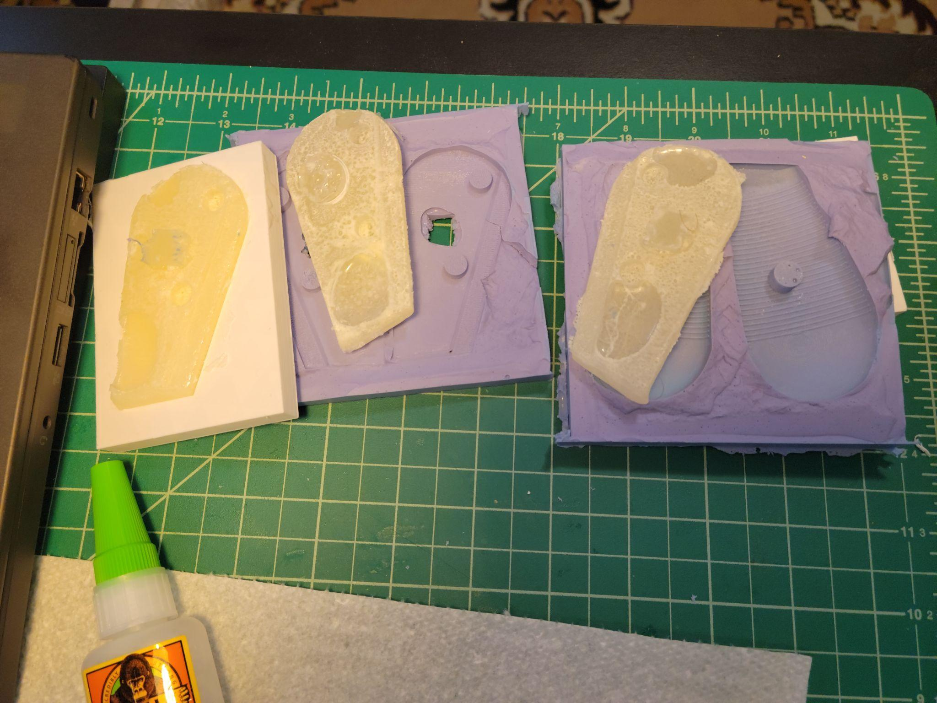
Resin Poured Into Molds

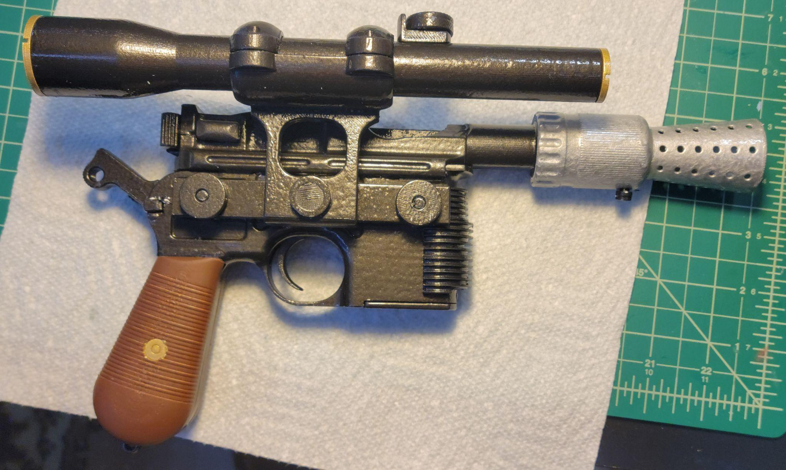
Final Blaster

Examples of Current Use in Theatre
Lastly, I wanted to talk to someone who has been using 3D printing in their theatre and ideally find someone who has used different printers. I looked online searching for theatres that were talking about their use of 3D printers. Through my search, I ended up talking with Chad Sweet who is the technical director at Reno little theatre. The theatre bought a Qidi tech X max for 1300 dollars and a CR-10 for 300 dollars. In my interview with Chad, he talked about the way they integrated 3D printing into their workflow, why they purchased a 3D printer, and the challenges they have encountered. He told me that the reason they invested in 3D printing was because of their small staff and how he viewed it as hiring a props artisan that would create exactly what he or the director wanted. They have used it many times for set-piece details in molding, props, and costume pieces such as plague masks.
One of the challenges Chad experienced was with the lower cost CR-10 printers which according to him took a lot more time and effort to get working than the Qidi-tech did. The CR-10 did create good prints but the time and effort that had to be put in to get it to work were not worth it to him. He did mention that with time the printer likely could be made more reliable but that was not something he was able to do currently. If given the chance again he would purchase another Qidi-tech for the theatre over a cheaper one because the issues that it presented were counterintuitive to why he purchased a 3D printer. His use case required reliability and ease of use in order to make the purchase worthwhile. Now, this does not mean that no theatre could utilize lower cost printers, if a theatre is willing to take the time to maintain and learn how they work they can still be very capable machines. But this should be taken into consideration when a theatre is deciding on what printer to buy.

How to Utilize It In Theatre
Ideally, I would like to use this research in some way to benefit Theatre and Dance Main Stage Production. A few ways I can see this happening are using 3D printing to make custom detailed and or functional props. Creating scale furniture or other objects for the scale set model. Or creating custom jewelry or things for costumes. I would like to use 3D printing to in some way benefit or assist the productions at UNH similar to how I printed a vintage model radio from the 1930s for the production of Dancing at Lughnasa my freshman year. This may be utilizing it in small ways but eventually, my hope is that we expand upon our use of 3D printing and it becomes an integral part of our production process. I would also like to teach others about what I have learned so the UNH Theatre and Dance department can continue to explore and use the benefits 3D printing can bring to the theatre.

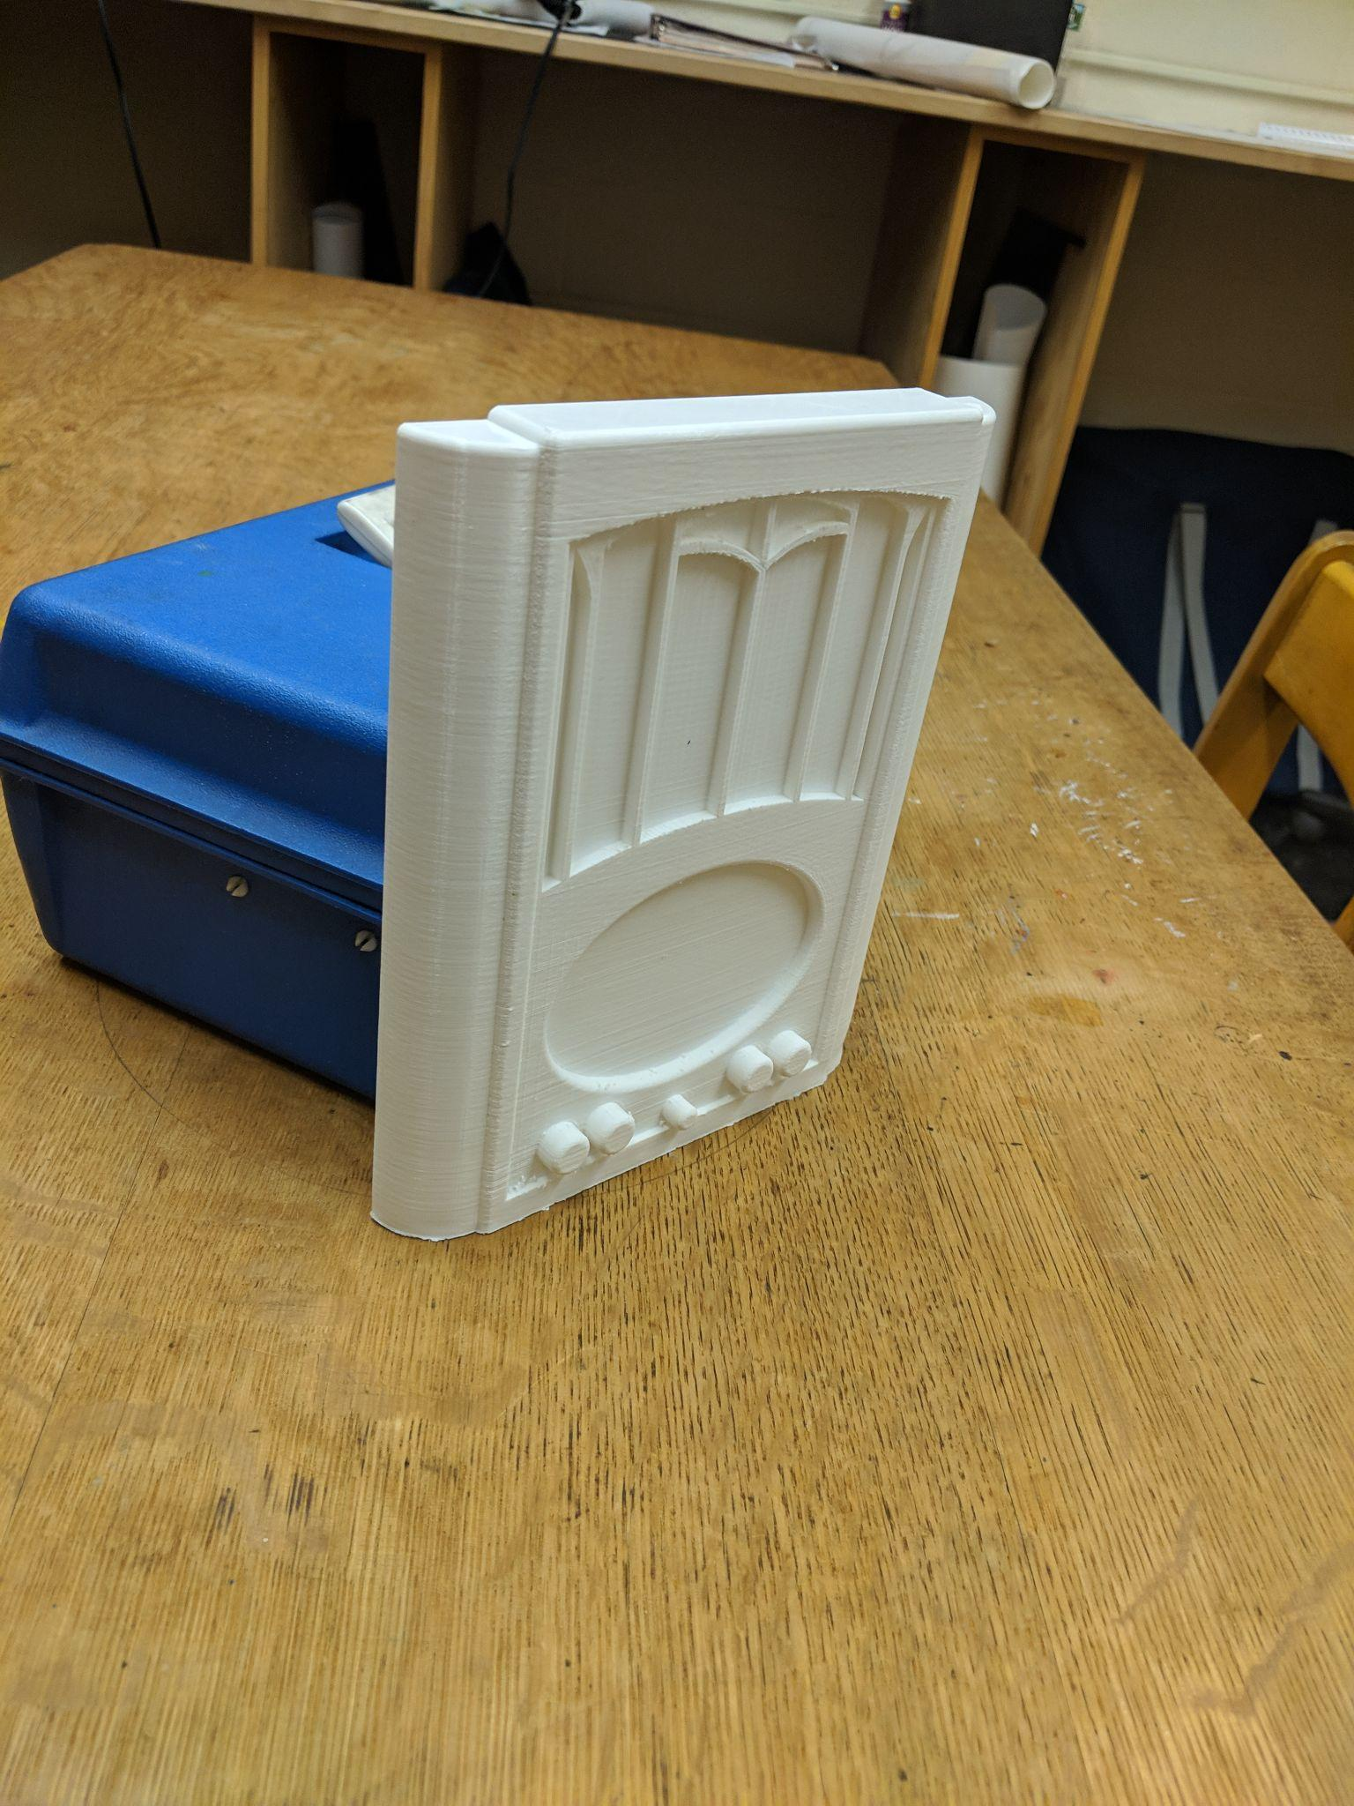
Dancing at Lughnasa Radio

This final semester for my research my goal was to explore new areas of 3D printing, continue with practical examples and find other research that has been done that may be helpful to those just starting out exploring 3D printing. To achieve this goal I decided to utilize new filaments, different printing types, and look at books geared towards introductory 3D printing. Additionally, I wanted to see if other types of printing brought any benefits to theatre and entertainment that traditional FDM printing could not achieve.

Resin Printing
Over the time between my last work on this project I acquired an Anycubic photon Mono X. This printer is a SLA type printer meaning it uses UV activated resin to create the models. This process works by lowering a build plate into a vat of UV resin. Below the resin separated by a clear film is a UV display panel that displays the image of each 2D layer. The layer is then cured to either the build plate or the previous layer and like traditional FDM printing, it continues this process moving the build plate up in order to add layer after layer to complete the final object. This process was very new to me and despite it still being 3D printing had an entirely different learning curve. There are a whole set of new parameters to account for and when failures occur it can be a messy and time consuming clean up process before a new print can be started. This was initially frustrating as many of the prints I was attempting would fail and deducing what went wrong was difficult.

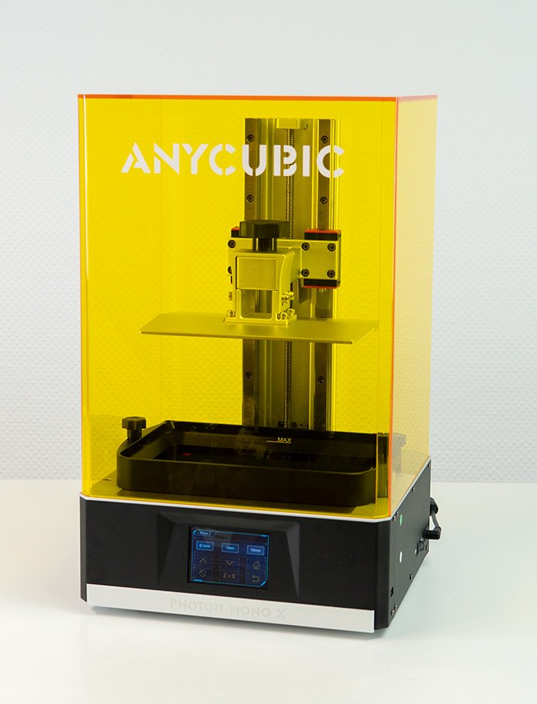
Photon Mono X

Eventually, however, I started to see some successes and was able to achieve more reliable prints. With this success the advantages of this different printing process become apparent. One of the biggest advantages of Resin printing over traditional FDM is the detail. With FMD printings there are often layer lines in the vertical direction of printing that occur when the top layers are printing on the layers before them. This can be remedied with smaller nozzles and post processing such as sanding but it limits the level of detail you are able to achieve. SLA printing can achieve much smaller details and layer lines are usually unable to be seen with the naked eye. This allows for smaller more detailed prints such as models and prints that require small details.

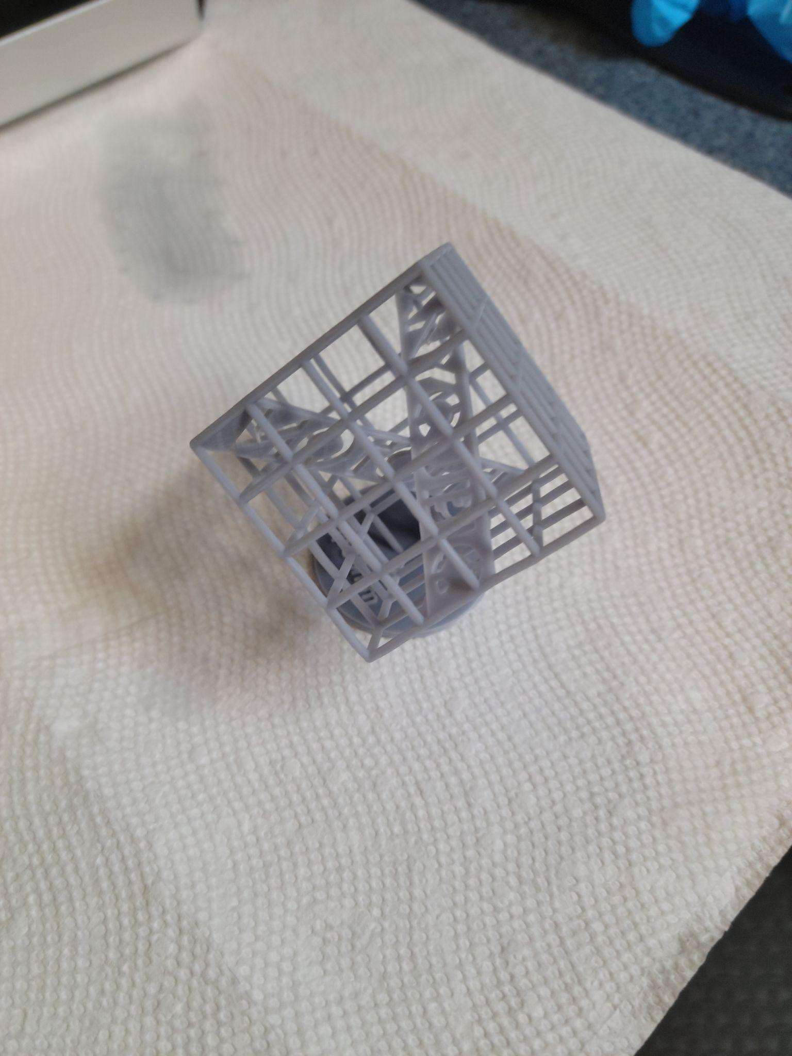
First Part Printed In Resin

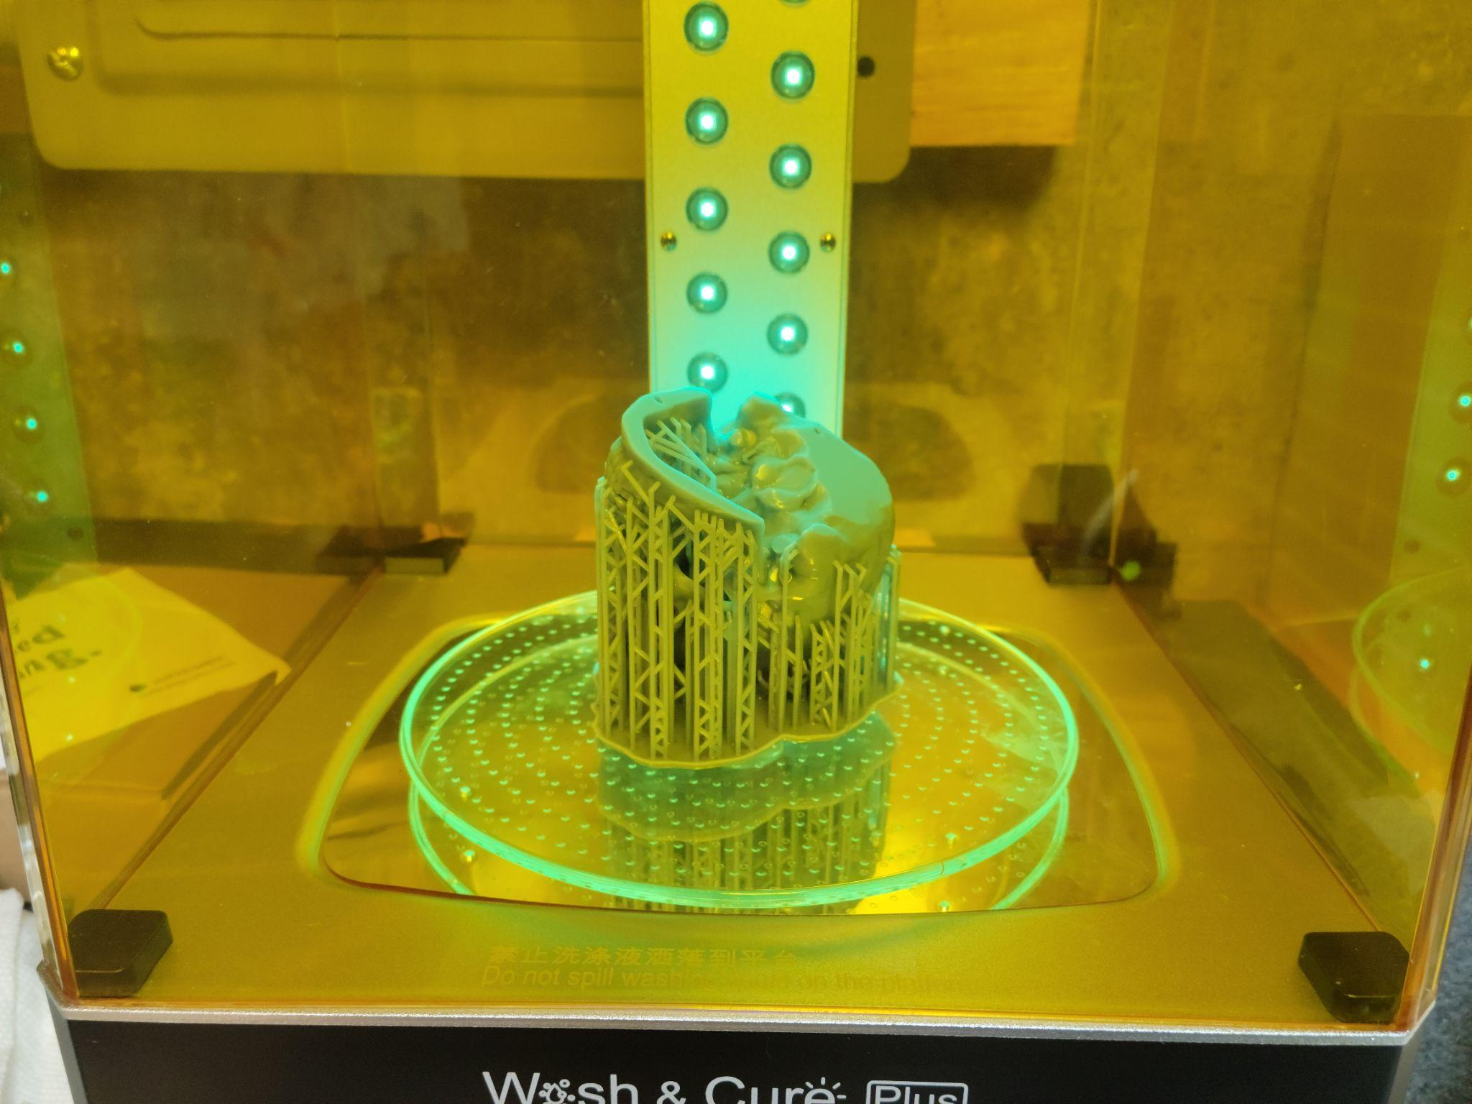
Resin Part Curing

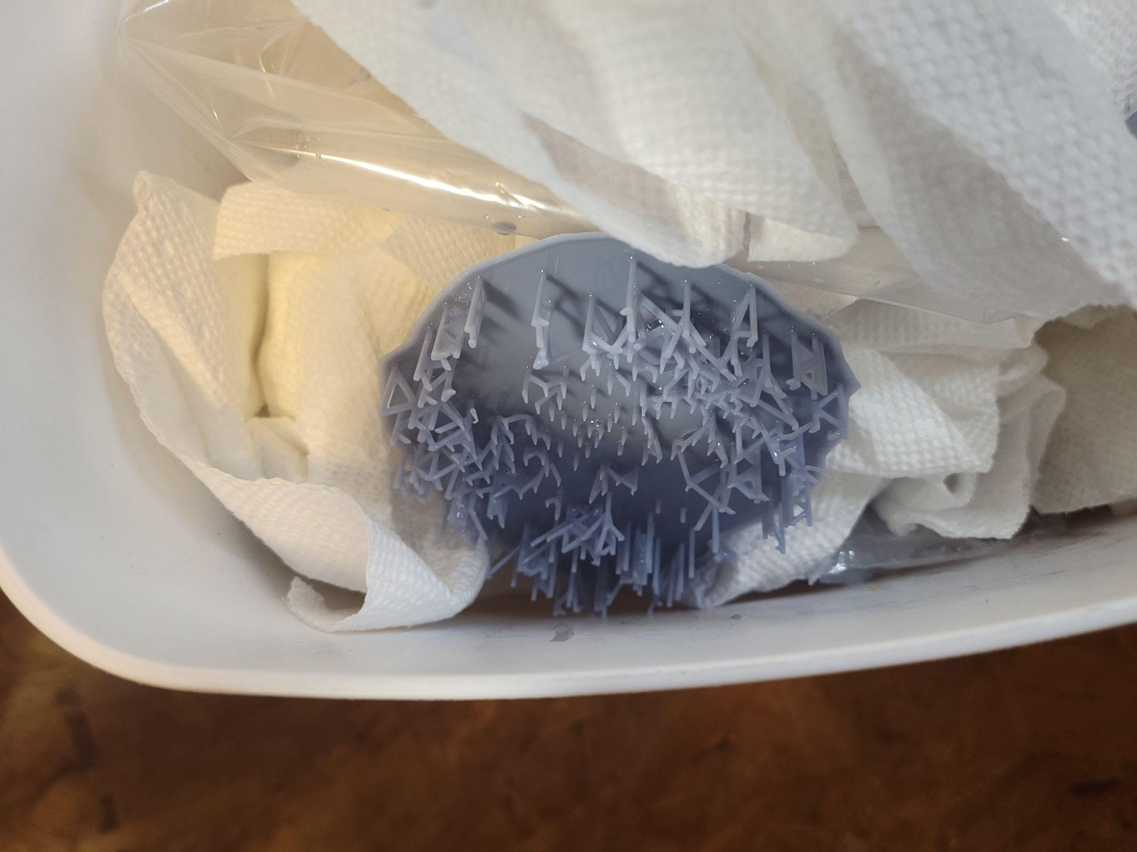
Failed Resin Print
This does come at a cost with resin printing having smaller than average build volumes than most similarly priced FMD printers with larger SLA printers costing more. The other downside is the cost of the material. UV resins are currently more costly than FDM plastics with a small bottle of resin costing about $30 while large spools of FDM filaments such as PLA cost only $20. They are also much more hazardous and the fumes they produce are noxious and avoiding skin contact with the uncured resin is advised. This complicated printing and cleaning up as gloves and masks have to be worn and a well ventilated room is necessary to prevent the build up of fumes.

Printing for UNH THDA She Kills Monsters
These are all complications I had to deal with when I was printing my practical examples for our department show She Kills Monsters in the fall of 2021. For this show, I printed three different human skulls. One was full scale supposed to mimic a real human skull and two of them would be about quarter scale. The large scale skull was printed in three sections on my Ender 3 FDM printer in PLA. This process was mostly smooth until I experienced jamming due to a worn out nozzle. This was fixed by replacing it with a new nozzle that solved most of the issues I was having and I was able to continue printing. The first of the smaller skulls was printed on my smaller FDM printer in ABS. This was my first time printing in ABS on this printer but despite it not having a heated bed which is usually required to prevent warping the print came out successfully. There were some spots that lacked detail but that was likely due to not setting the temperature high enough on the nozzle which caused some under extrusion. This hoover didn't affect the final piece too much as after sanding and painting many of these defects were covered up.

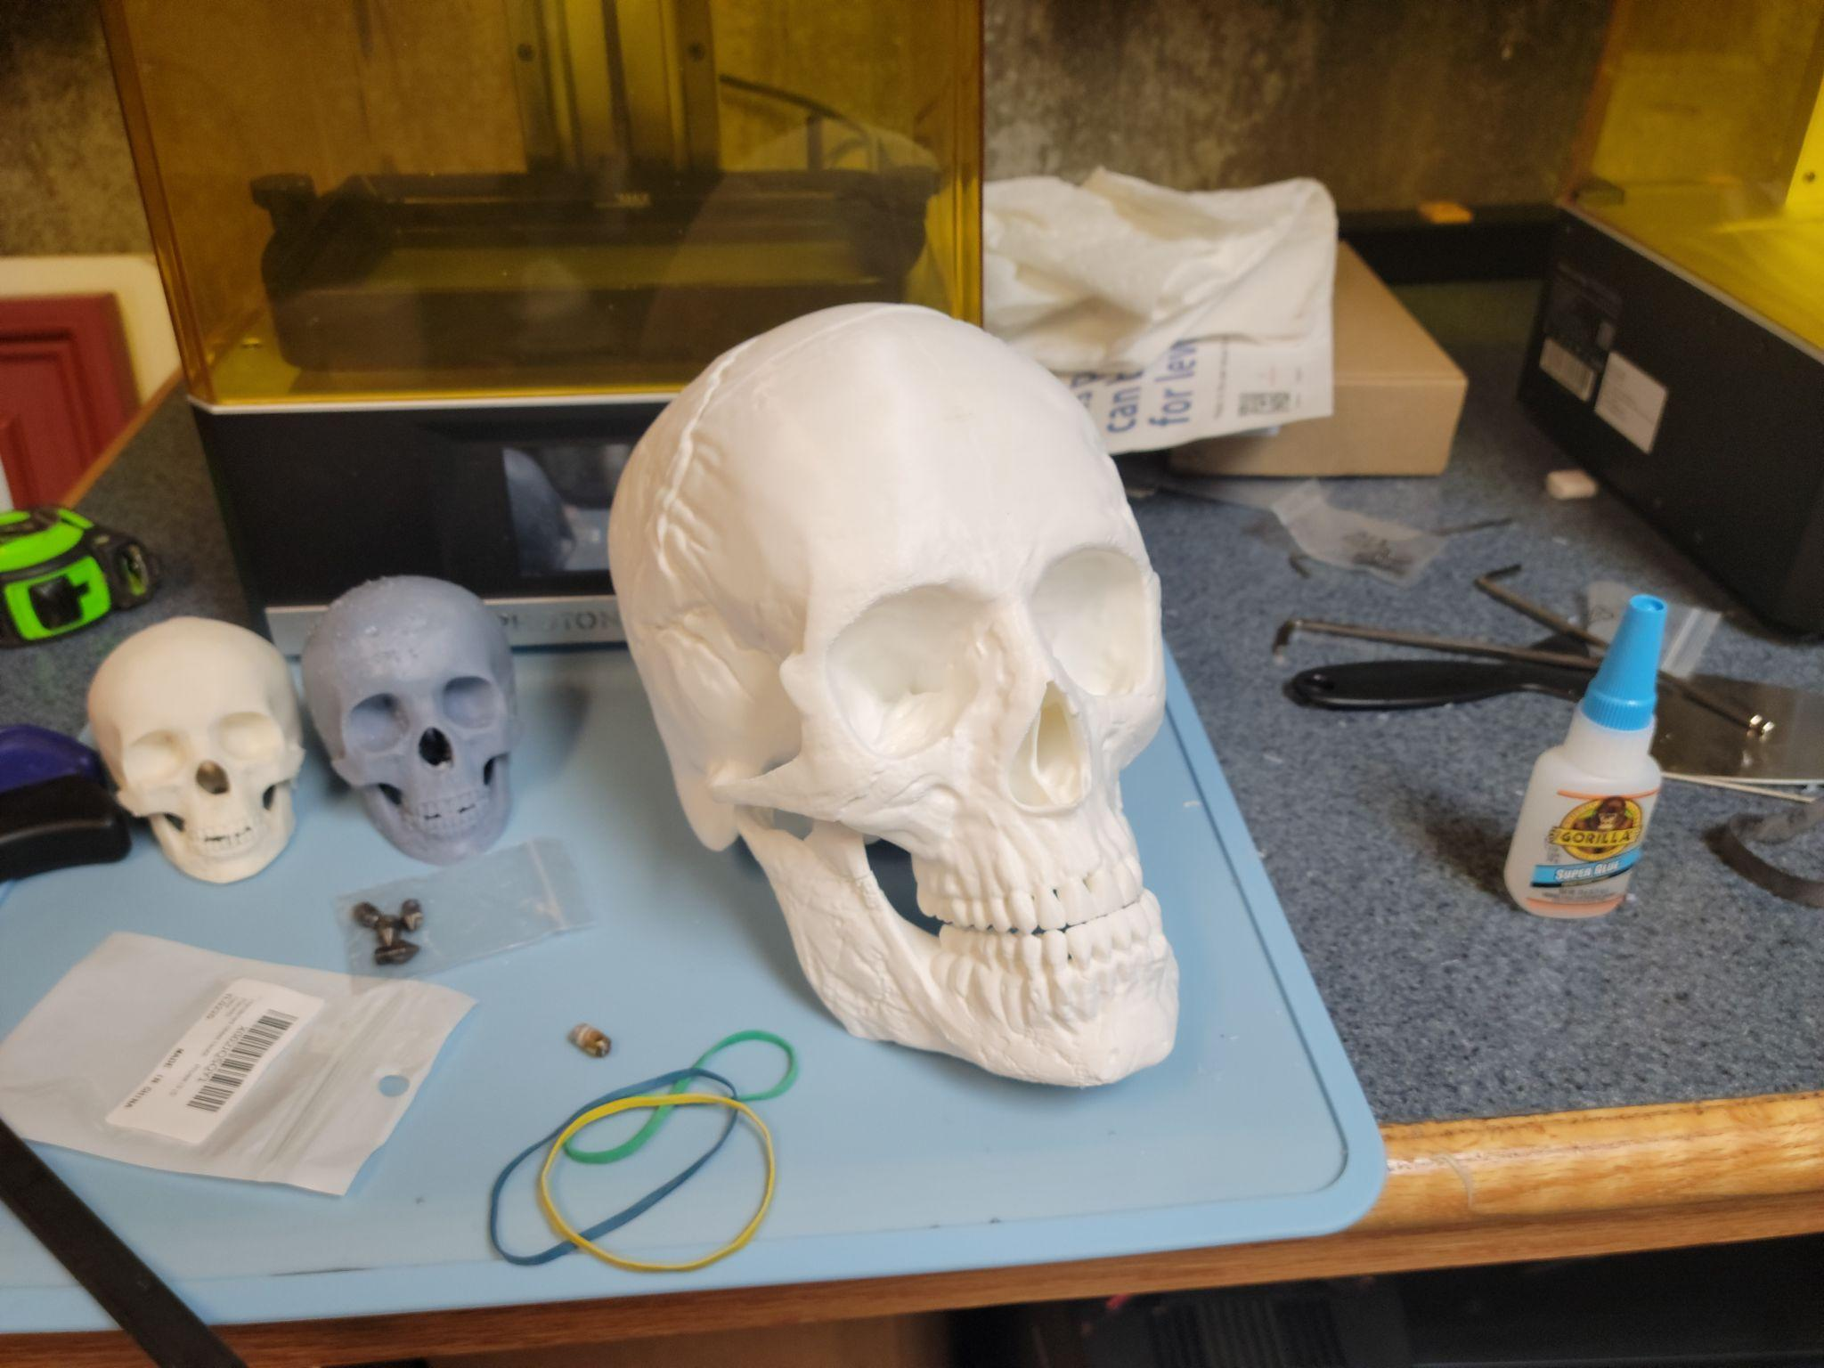
Skulls Before Finishing
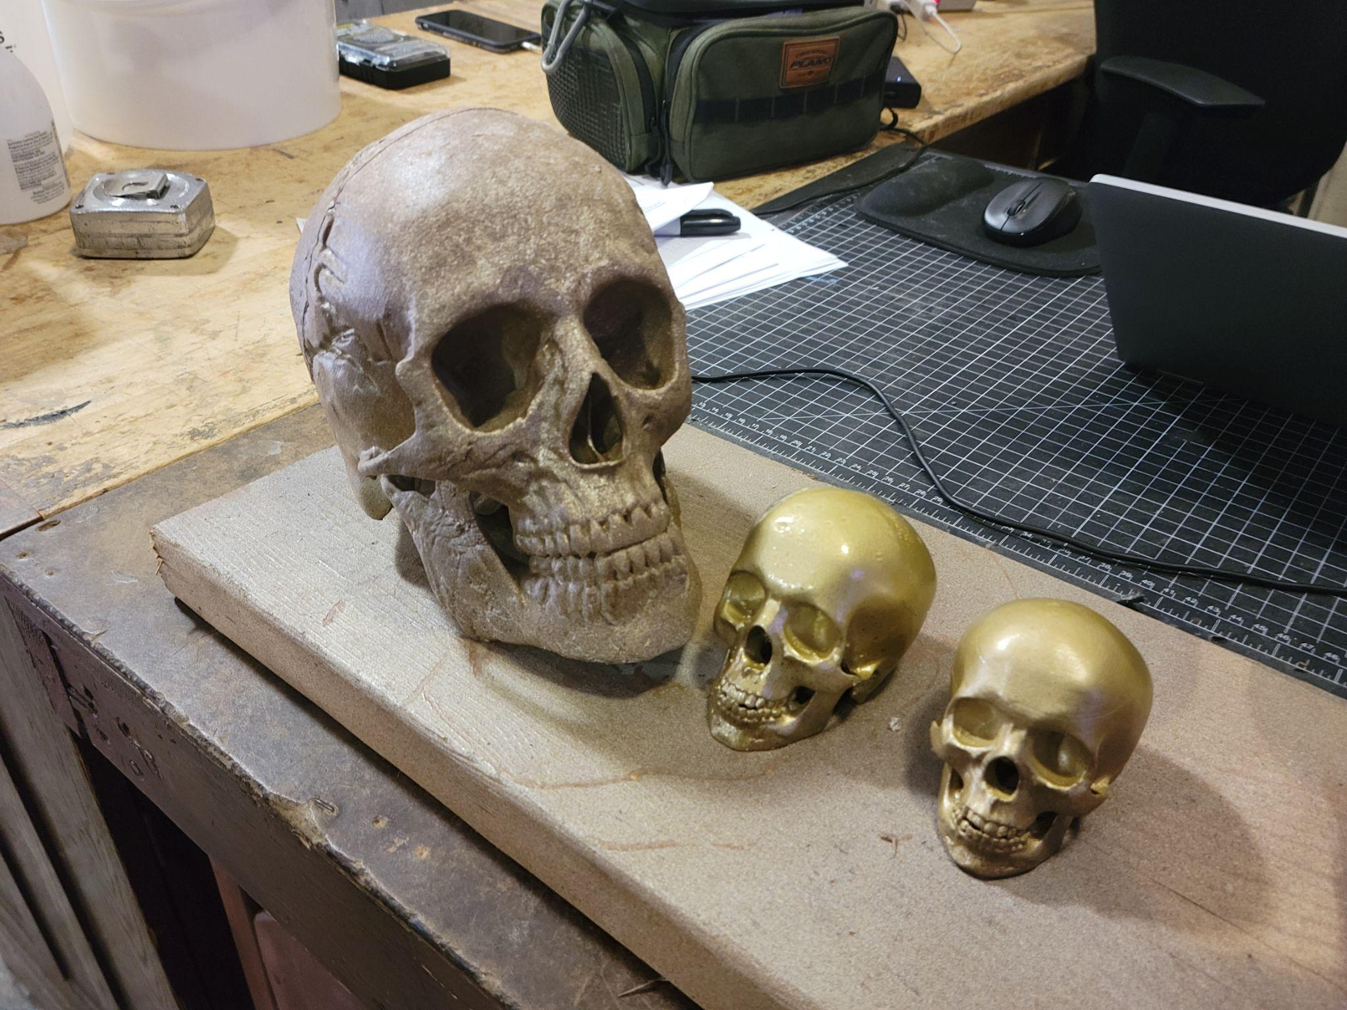
Skulls After Finishing
The last small skull was printed on my resin printer. Because of its shape, I had to hollow the inside of the skull to save on material and weight. Because of this and the orientation of the print I had to create two small holes in the CAD model in order to allow the uncured resin in the center to drain out. This printing process took a few tries but eventually after moving to a different slicer and upping the exposure time of my first few layers I was able to achieve a successful print that really showed off the detail you can achieve using a resin printer. Comparing this to the smaller FDM print off the printer finish was vastly superior and it only required some sanding to smooth out points left by the support material. All of the parts that did not have support material were smooth enough right off the printer.

Wood PLA Filament
After this, I went back to the FDM printers to experiment with a new type of filament. I picked up some food filament to try with my Ender 3. This wood filament uses a mixture of PLA plastic and wood fibers to create a wood-like material that can easily be sanded and stained just like actual wood. This new filament required a new hardened steel nozzle for my printer as a regular brass one would have been quickly worn down due to the other materials in the plastic. I first tried to print a figure of Groot from Marvel's movies. This first attempt however showed me some of the issues that had to be overcome in order to print with wood filament. Firstly it had a lot of stringing due to the other materials in the filament and the fact that stopping the flow of the filament using something called retraction in order to move across the part, does not work well as the plastic binder can burn off creating clogs and possibly causing the wood fiber to burn.
I did eventually achieve successful prints but they were not reliable and it depended on the model's geometry. One of the suggestions when printing with this filament is to use a large diameter nozzle. This can help prevent clogging but comes at the cost of print resolution. Because of the difficulty of printing with this, while it does offer some benefits such as a better finished look that resembles wood, I decided to not continue printing with the filament at the time. Compared to PLA it is more difficult to print with and still could require post processing in order to achieve the look desired, because of this the advantages did not really present themselves that would make it a better option to use over alternative filaments.
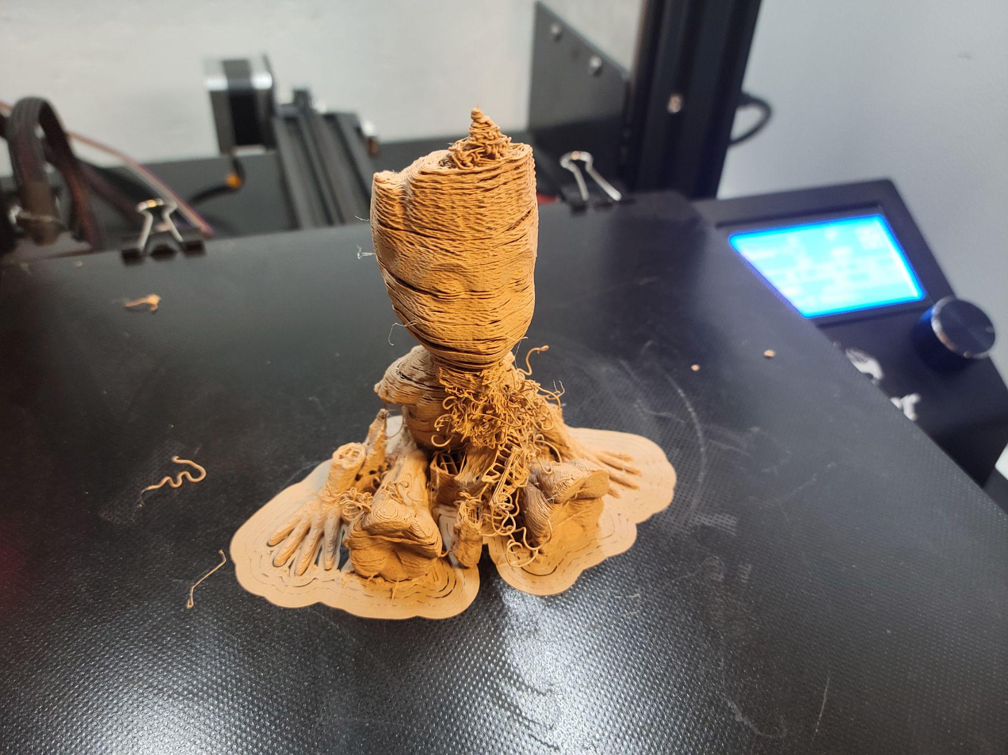
Failed Wood Print

3D Printing Resources
I also wanted to explore some of the resources that were available to those just starting to explore 3D printing. I started out learning about 3D printing from resources online and my own experiences trying to 3D print. One of the best resources I found was the 3D printing communities on Reddit and Youtube. These resources are extremely vast and welcoming with most questions someone might have been able to be answered by a video online. If you have more specific questions or problems the online forums often have quick replies and helpful info. I have utilized this multiple times when having specific issues printing and have received helpful answers in about a day. Some of the channels and forums I have used include; 3D Printing Nerd, R/3D Printing, Thomas Sanladerer, and R/Ender 3. All of these have been great resources for me and have helped immensely while learning about 3D printing.

Conclusion
The opportunity to explore this topic has helped me grow my interest and experience in both my interest in 3D printing and in theatre. The research I have done has led to discovering how the technology has been used, and finding innovative ways it could be used in theatre. The printing that I have done myself has pushed me to explore new types of printing such as SLA and experimenting with new materials and allowed me to gain more experience in printing. I hope my research has also helped the Theatre and Dance department to start adopting 3D printing into their workflow. They have already purchased their first 3D printer based on the information from my research, a Creality Cr10 Plus. I hope to continue to utilize what I have learned and help others in theatre take the advantages that 3D printing can bring to the entertainment industry.

Image Gallery

First objects printed for project
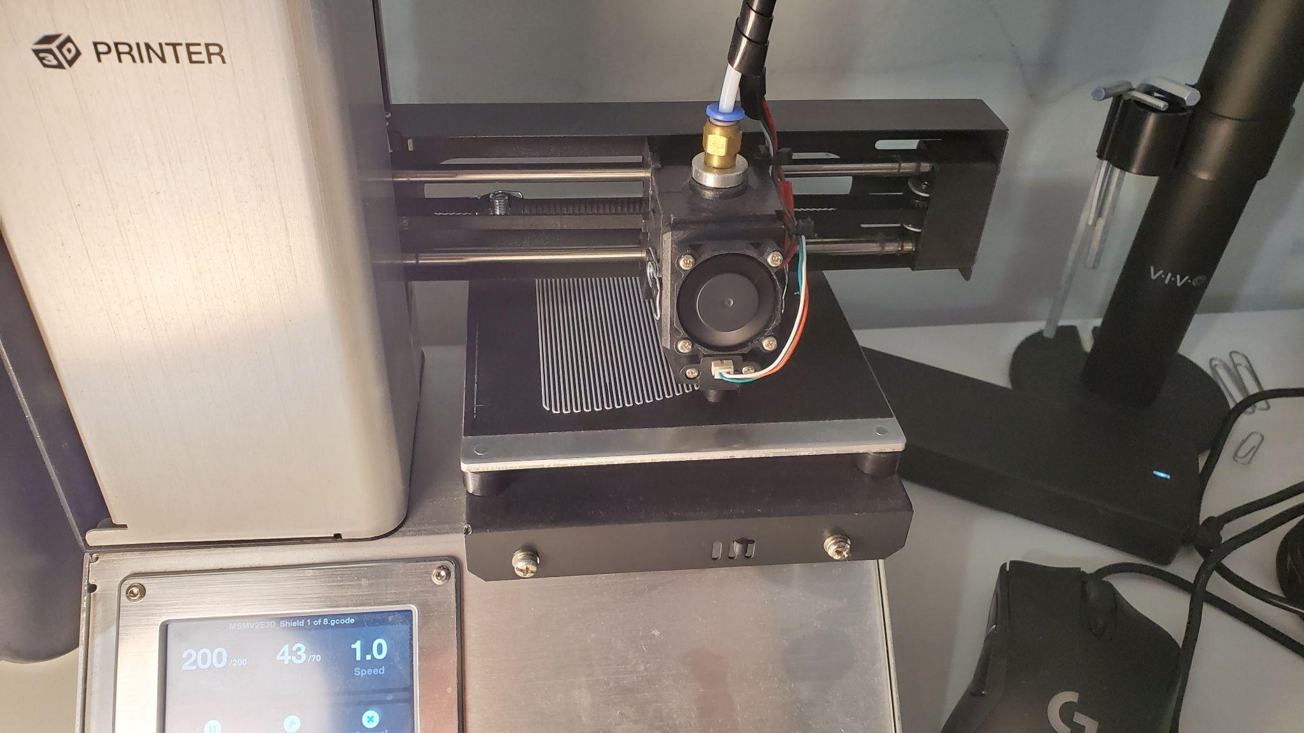
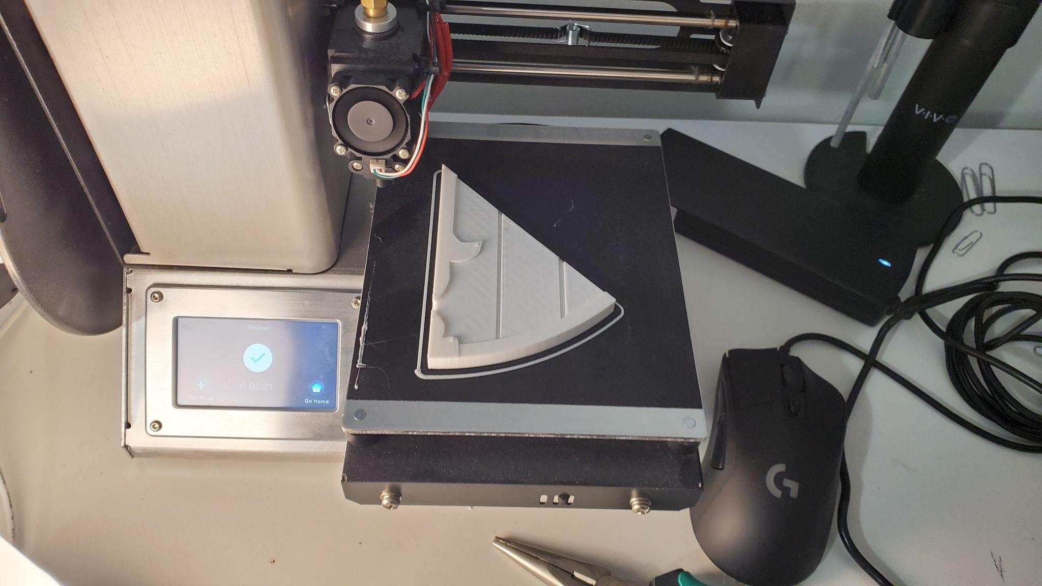

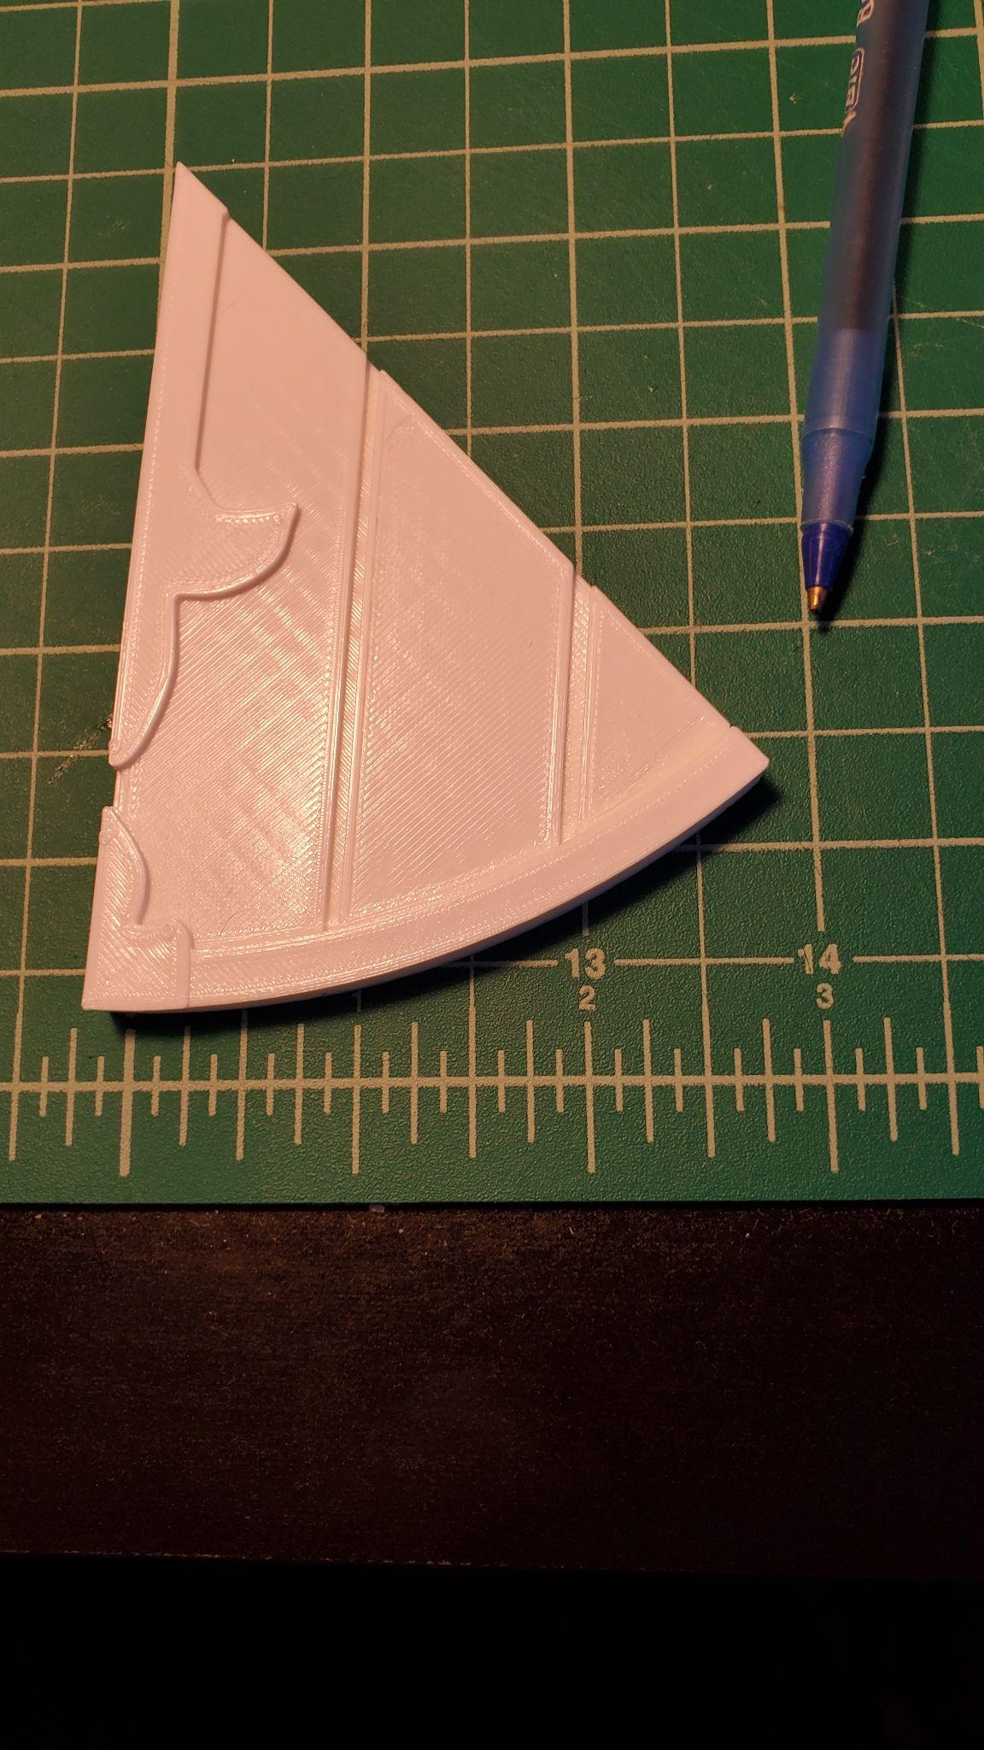

Drain to Catch water from leaky pipe in apartment
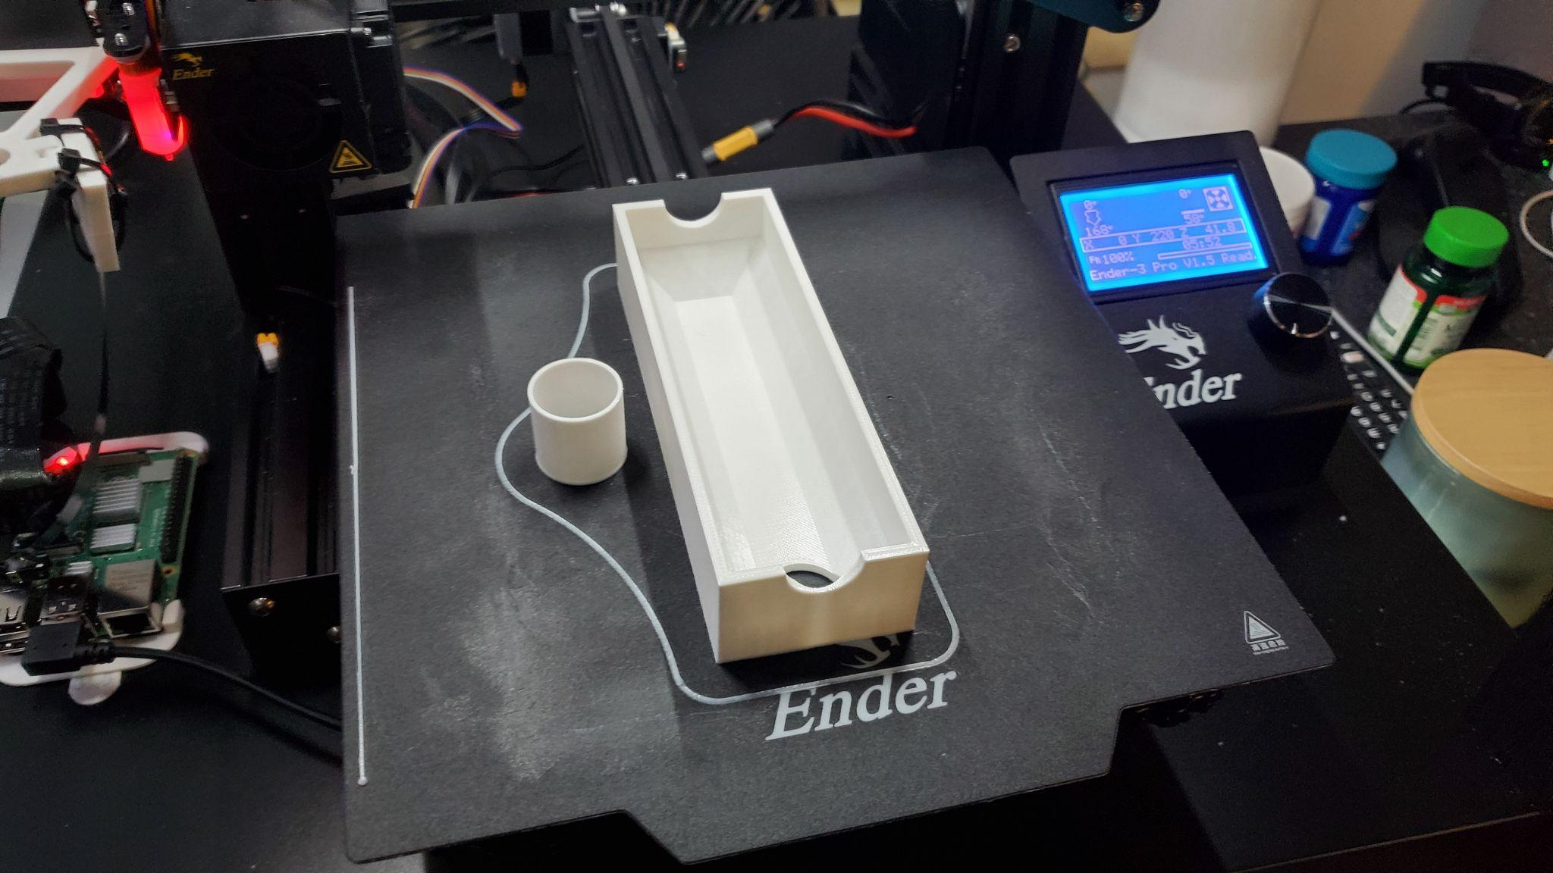
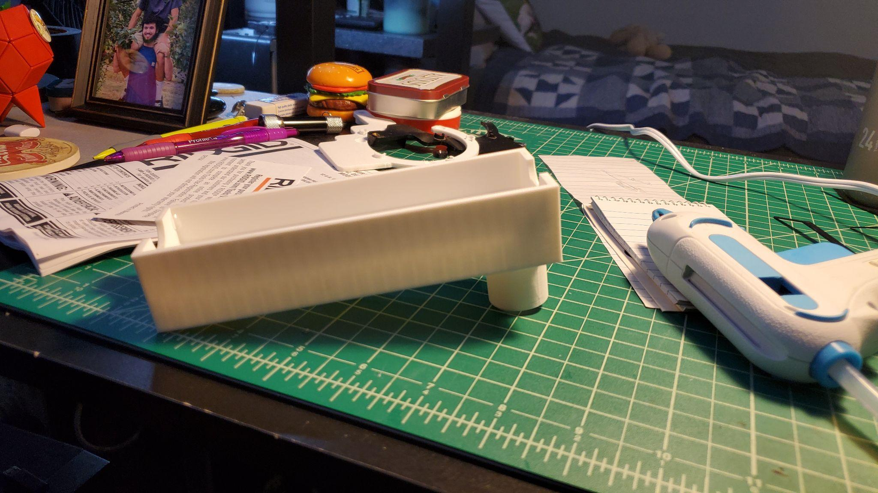

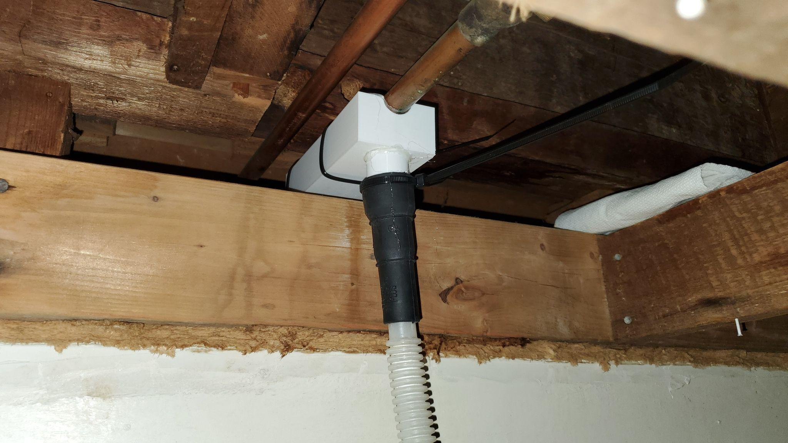

Small Test Models to Calibrate Printer
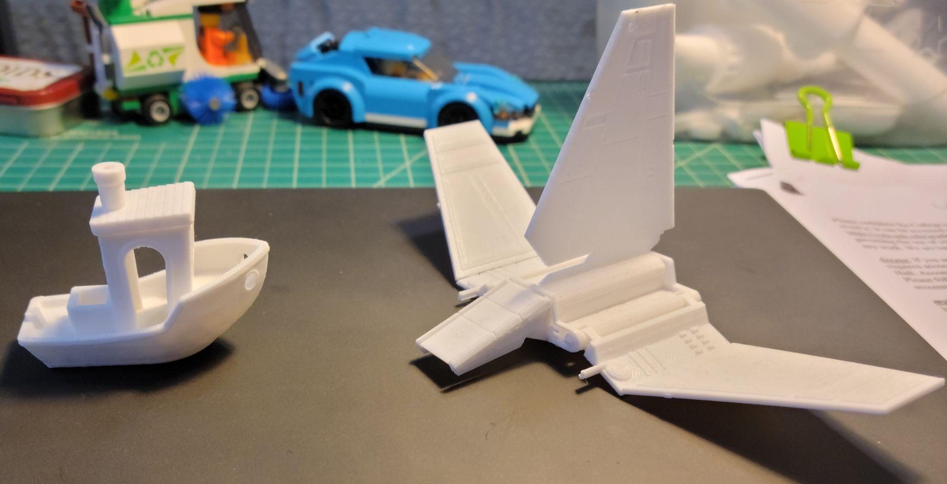

Progress photos of building the Blaster

Sanding
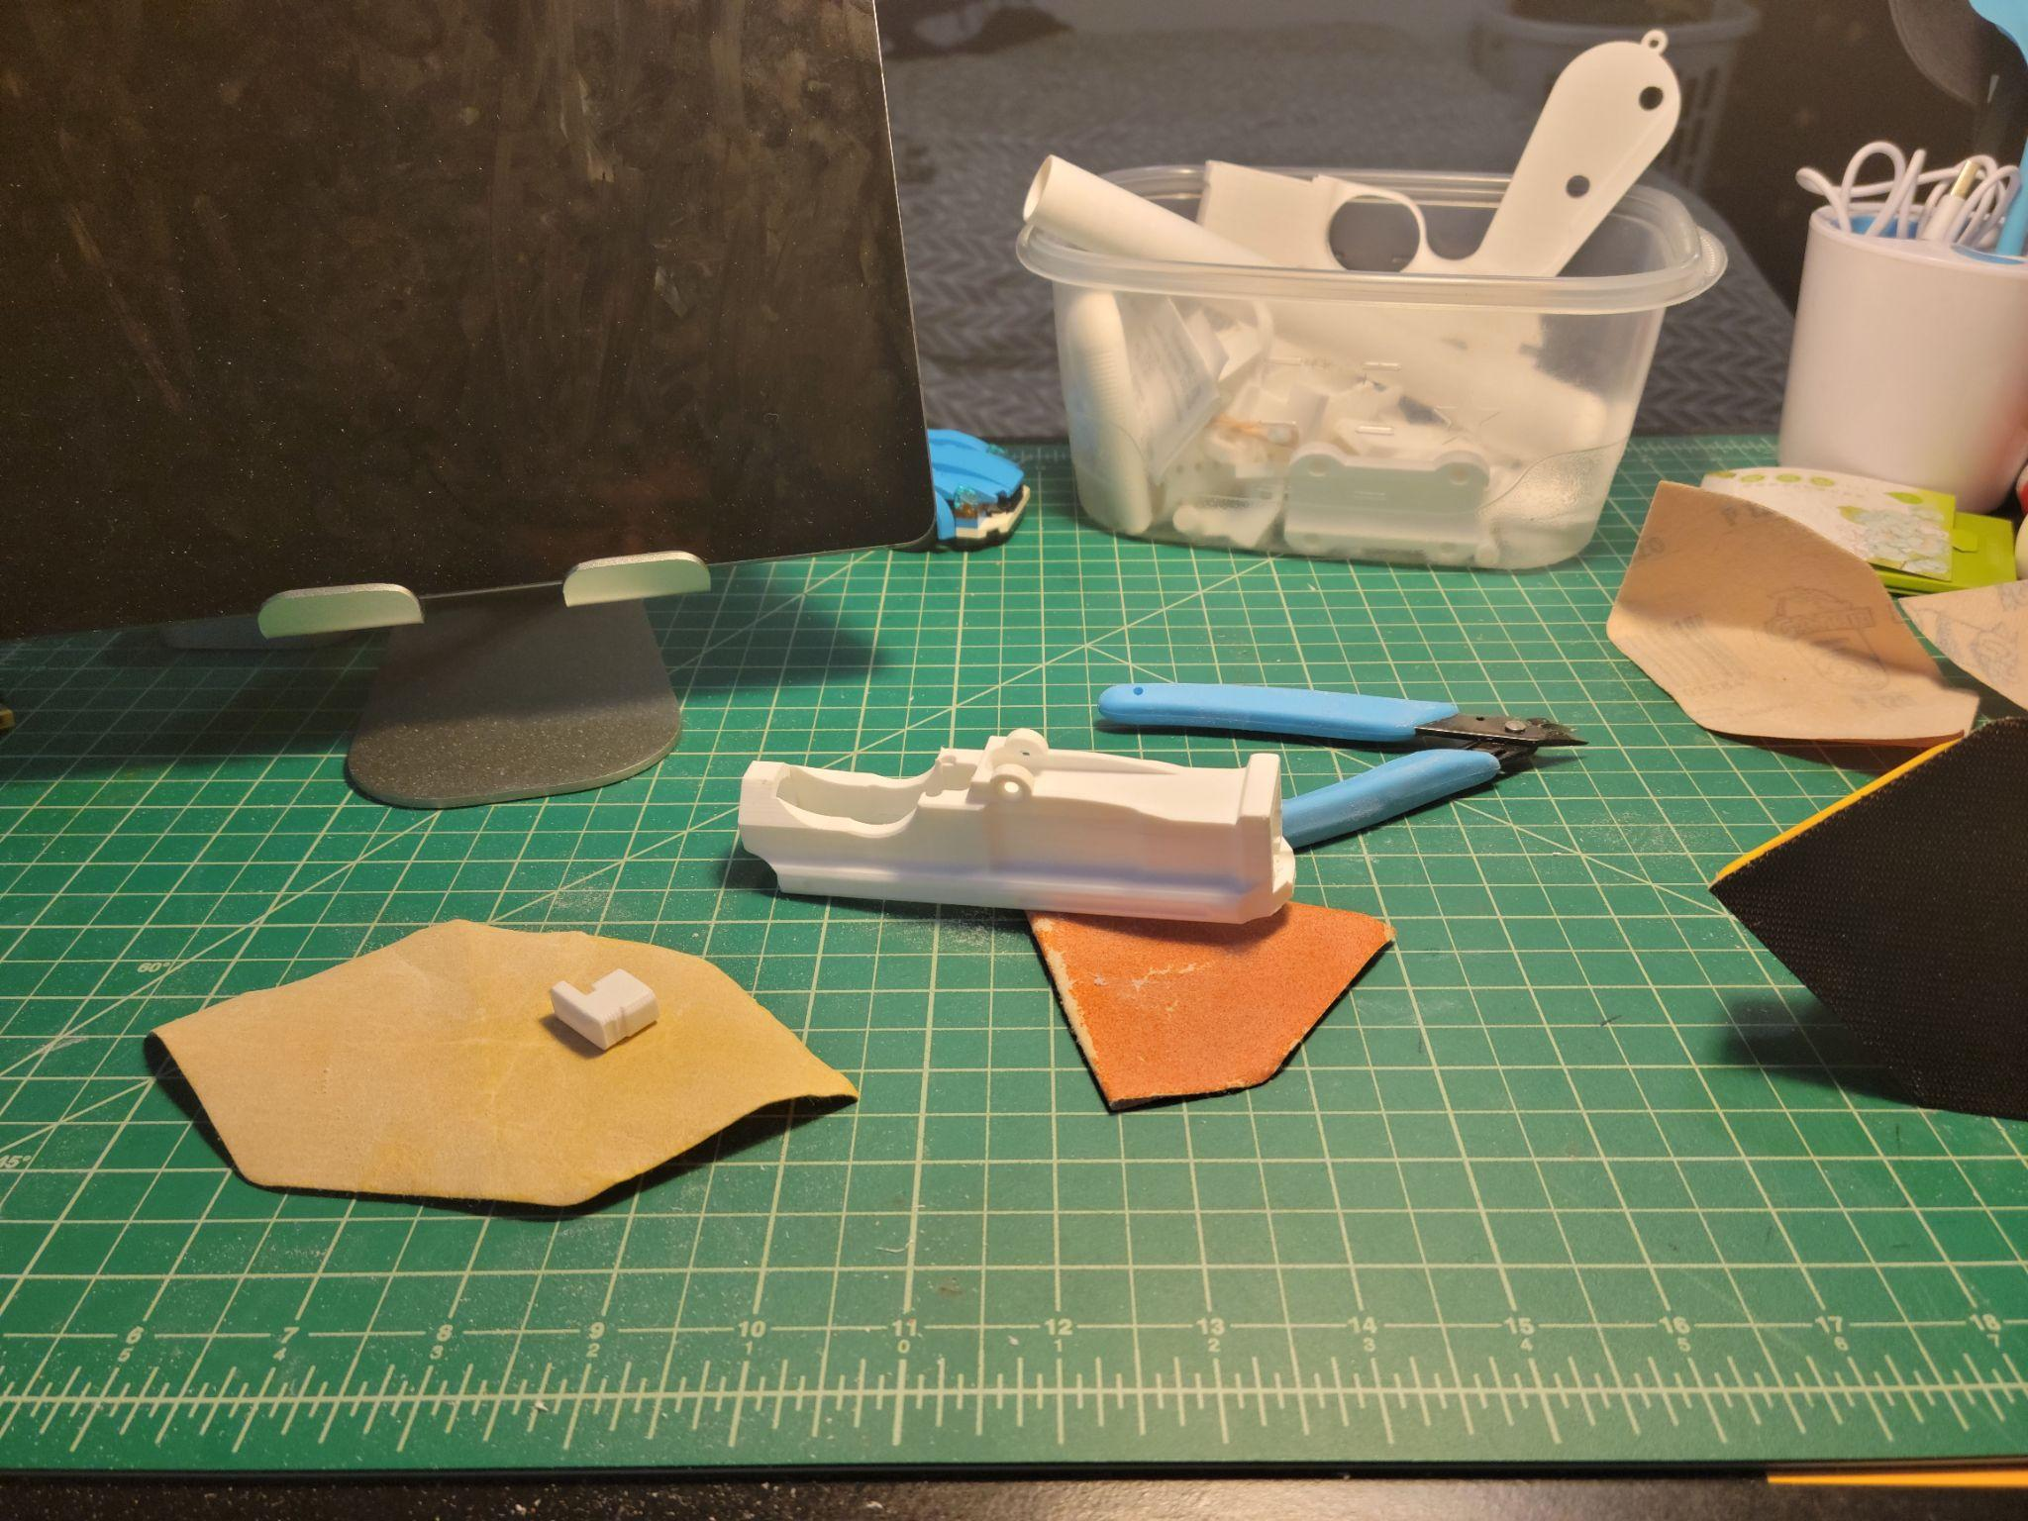
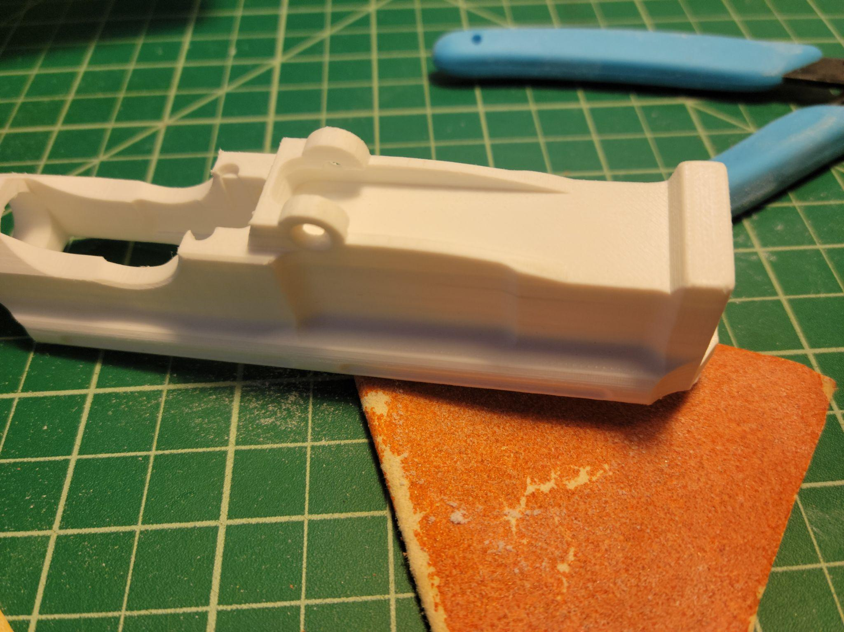

All of the Parts Prepped
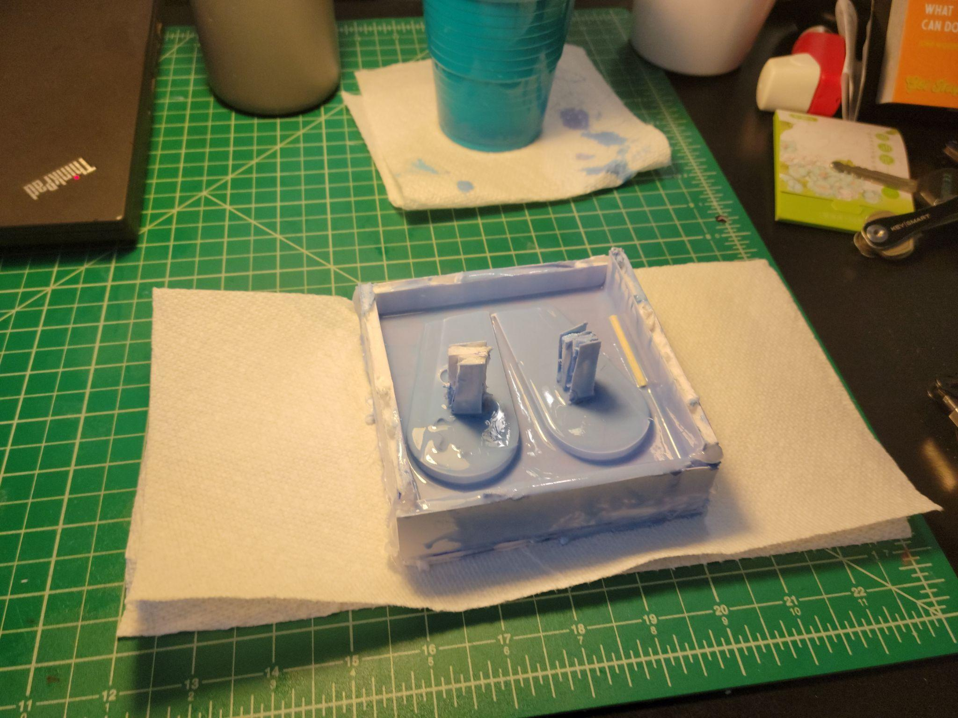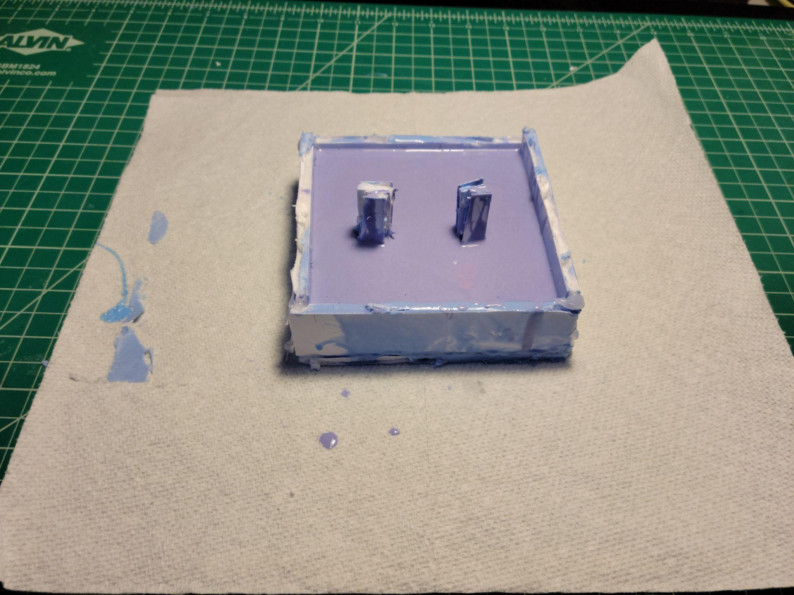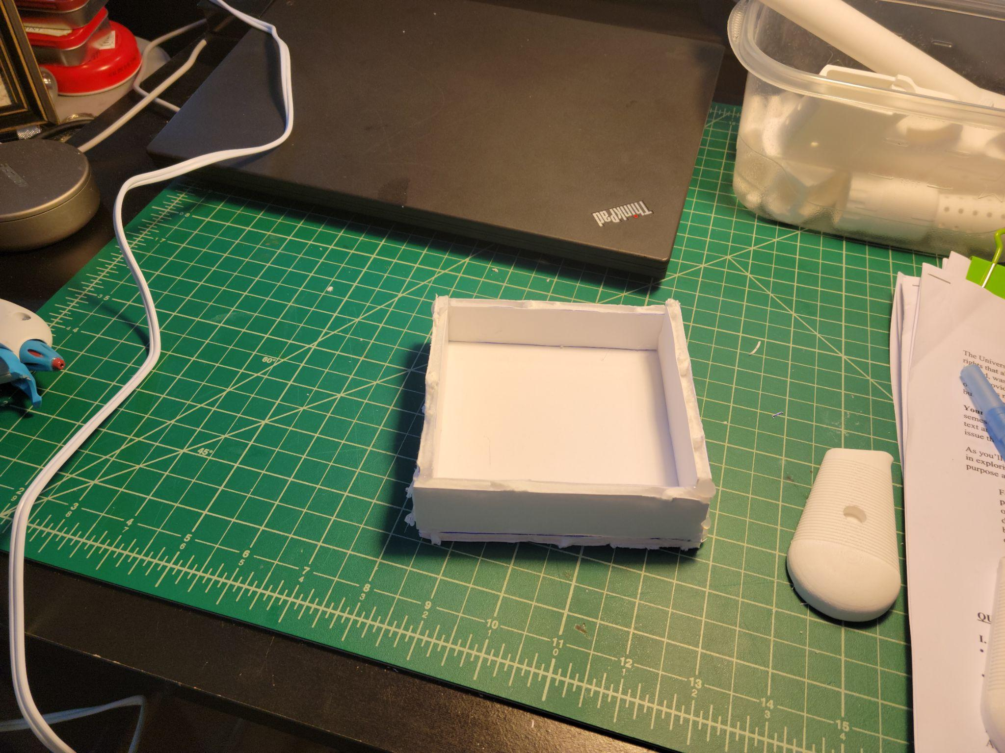

Casting

Painting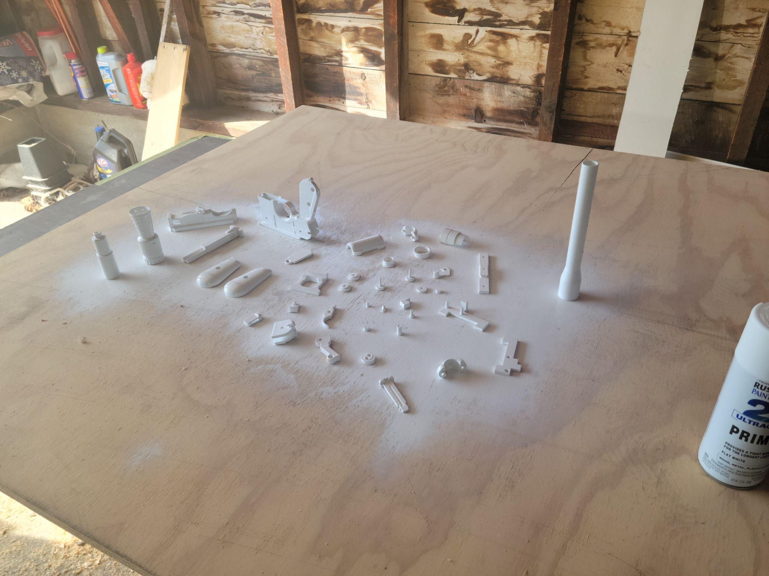
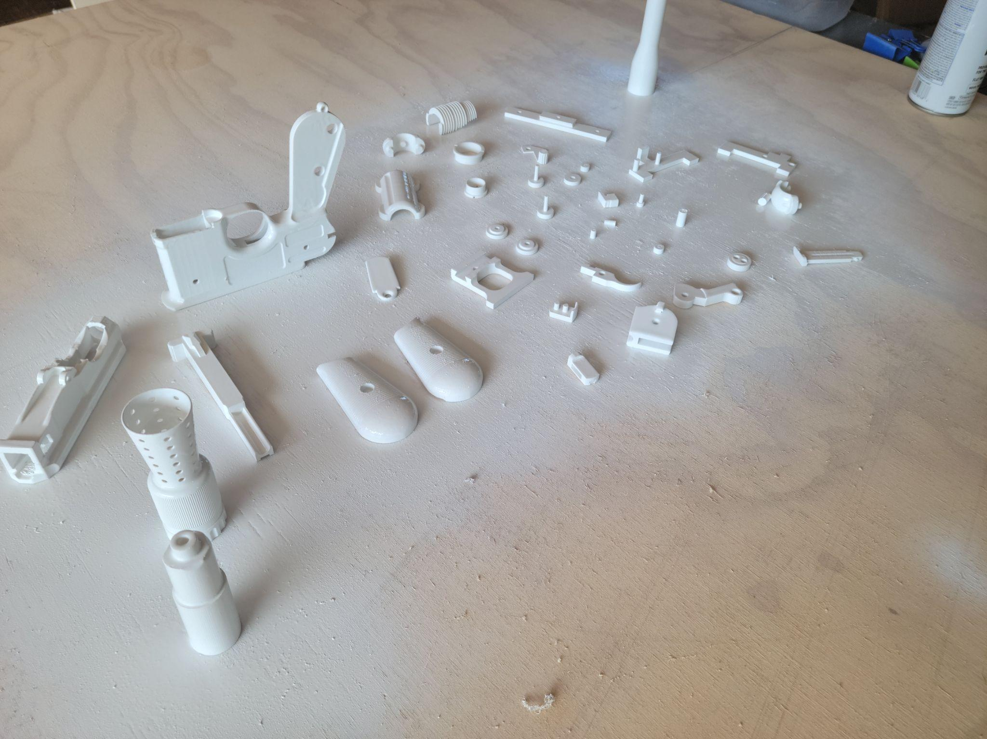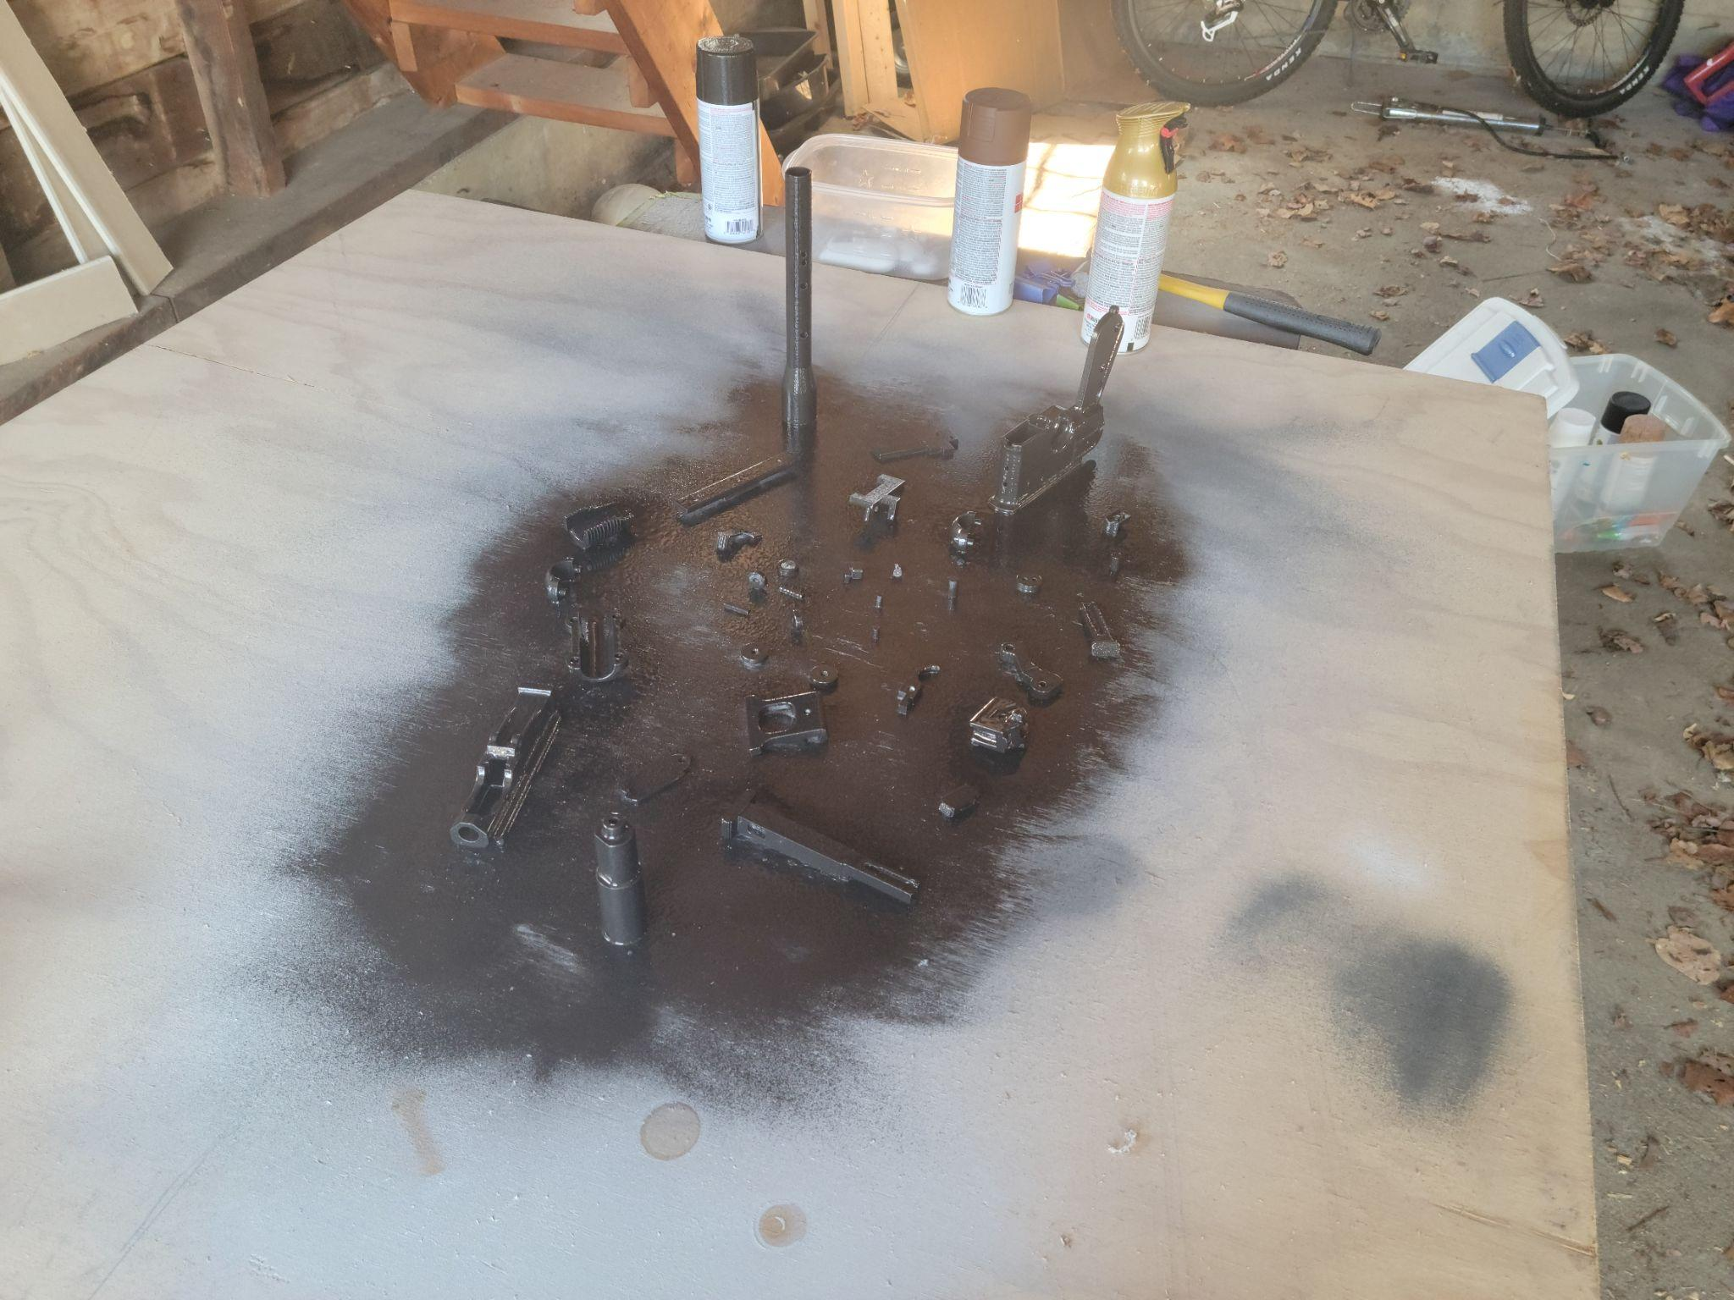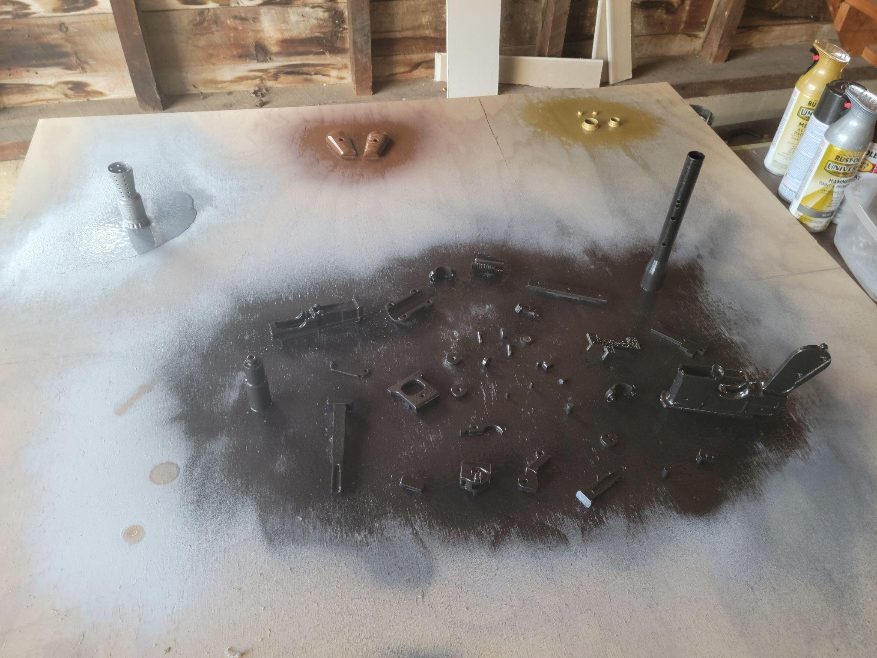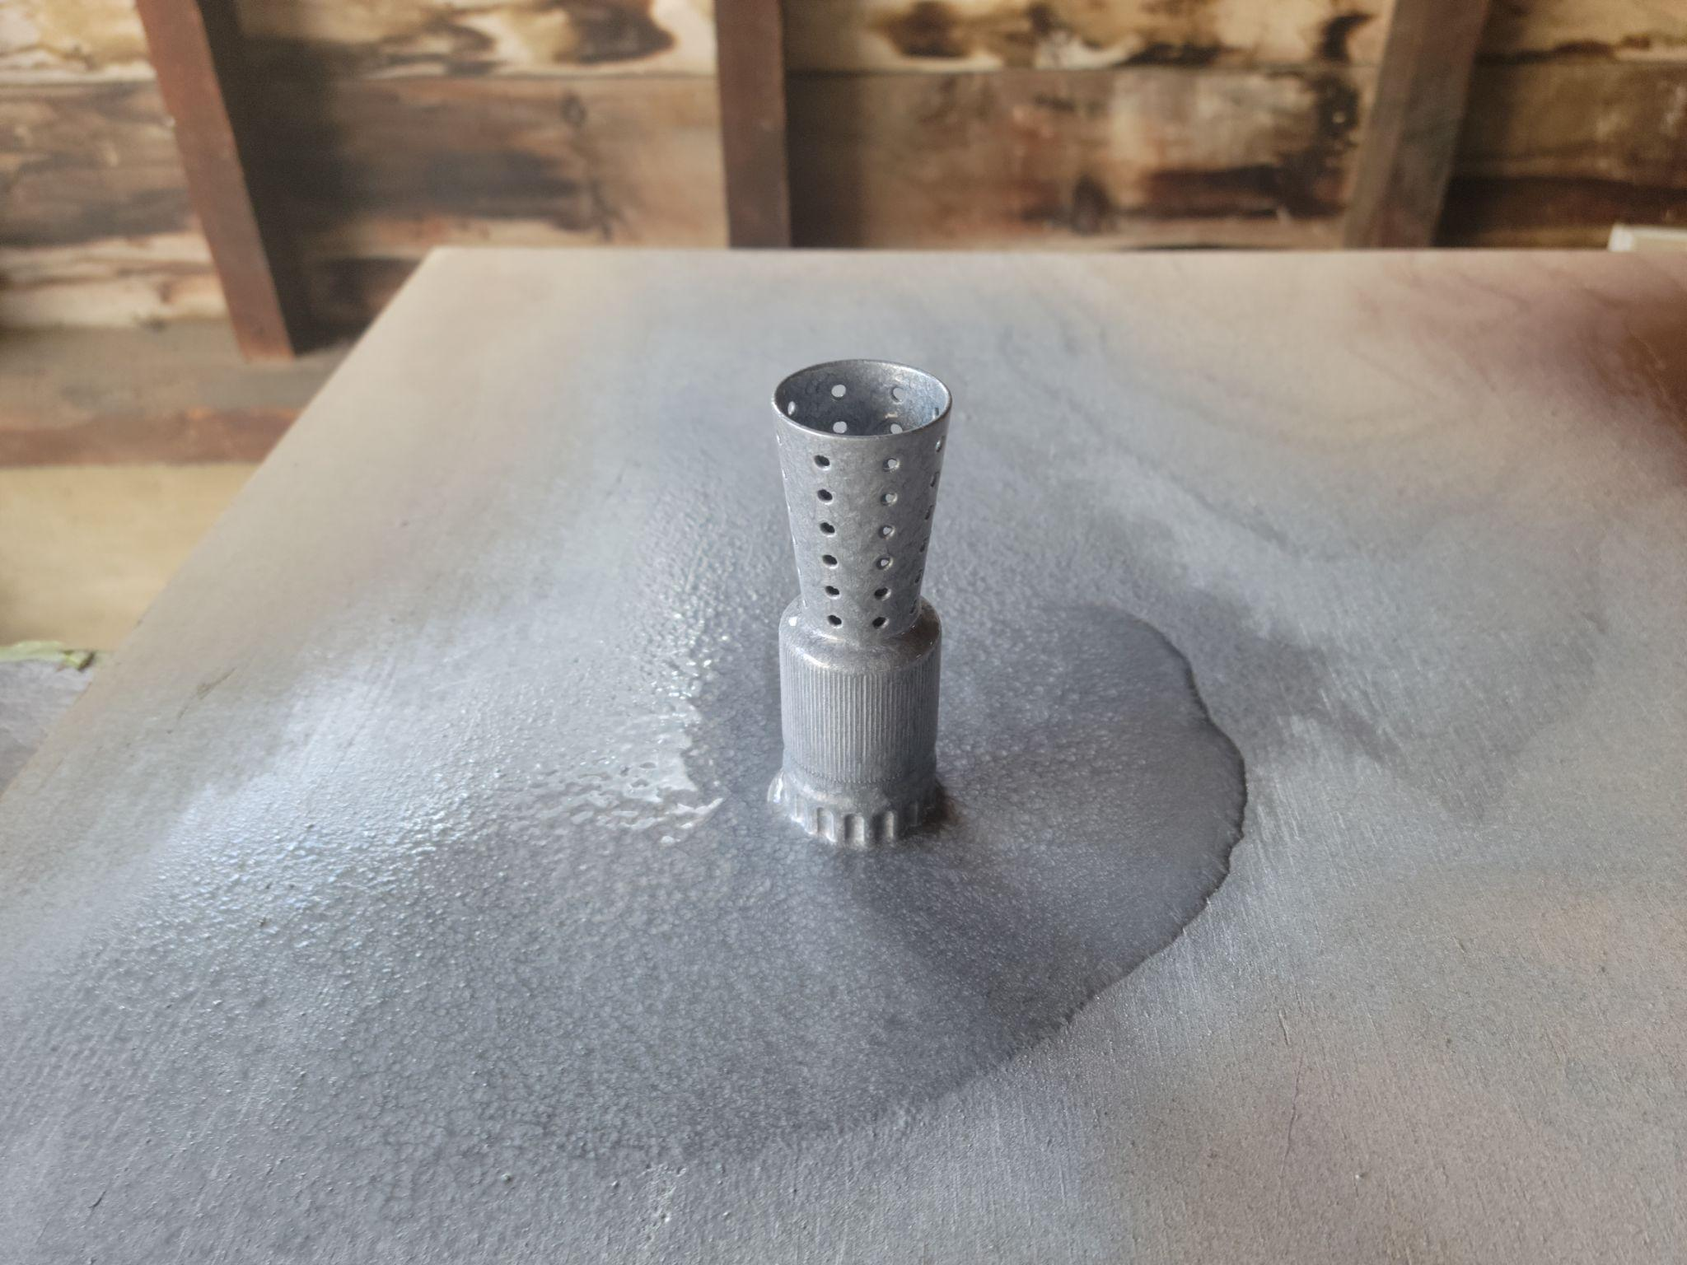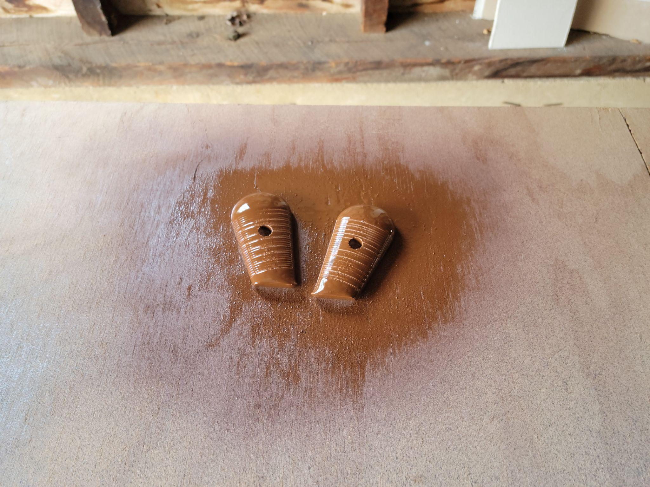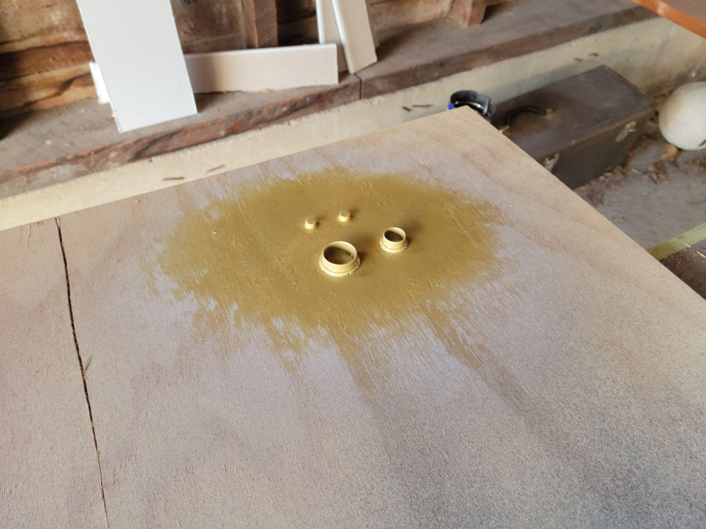

Final Assembly

3D Printed Working Wrench
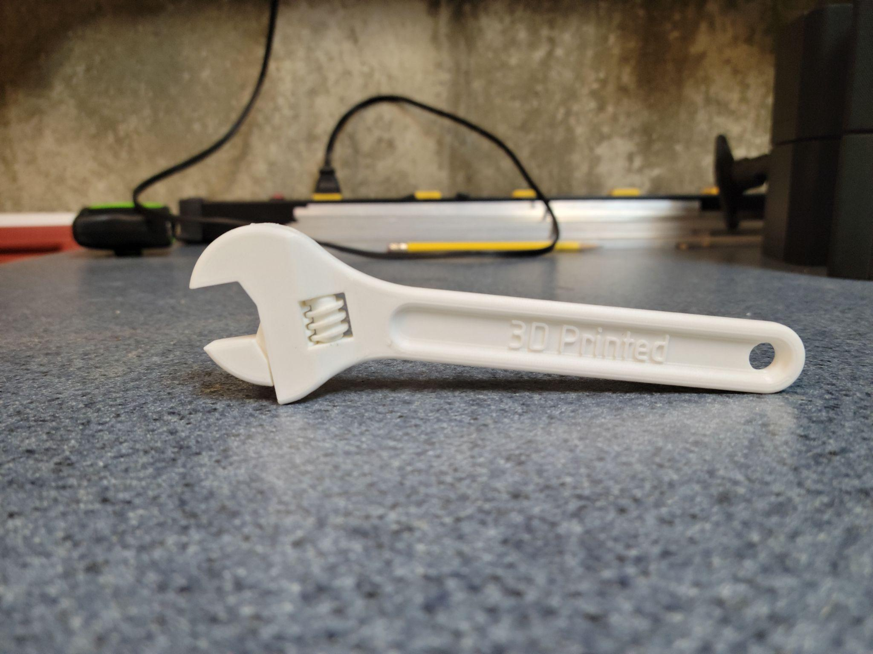

Lithophane
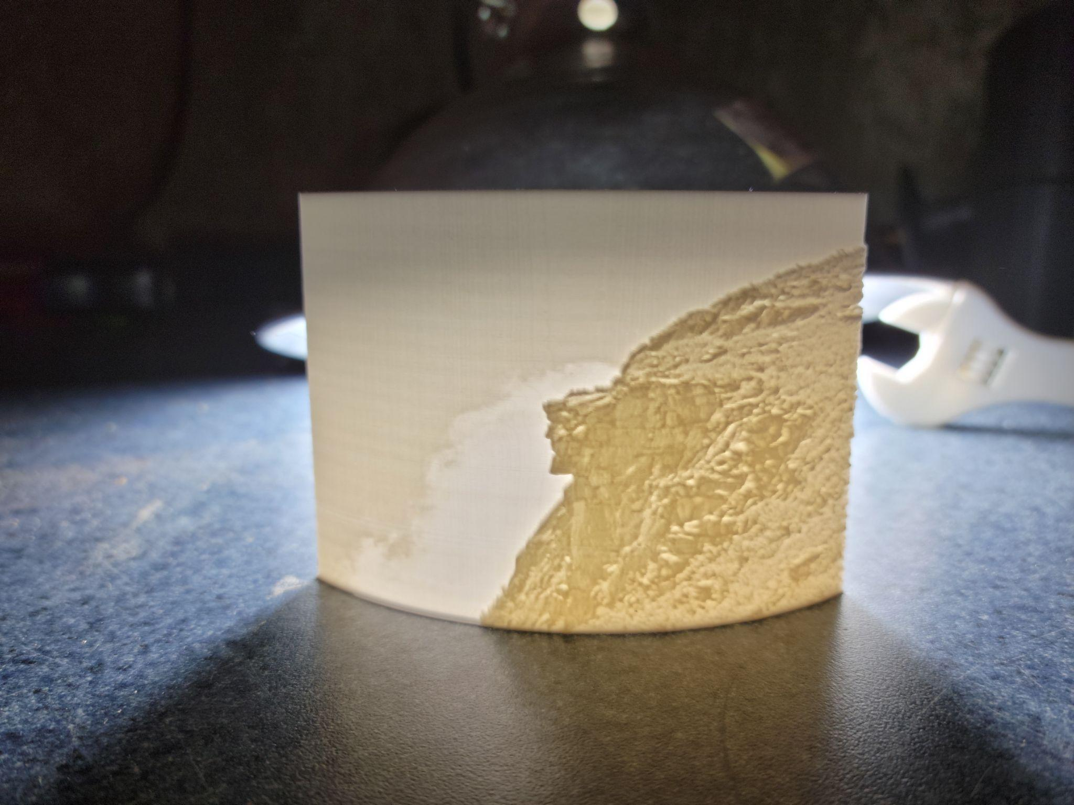

3D printed T Rex Skull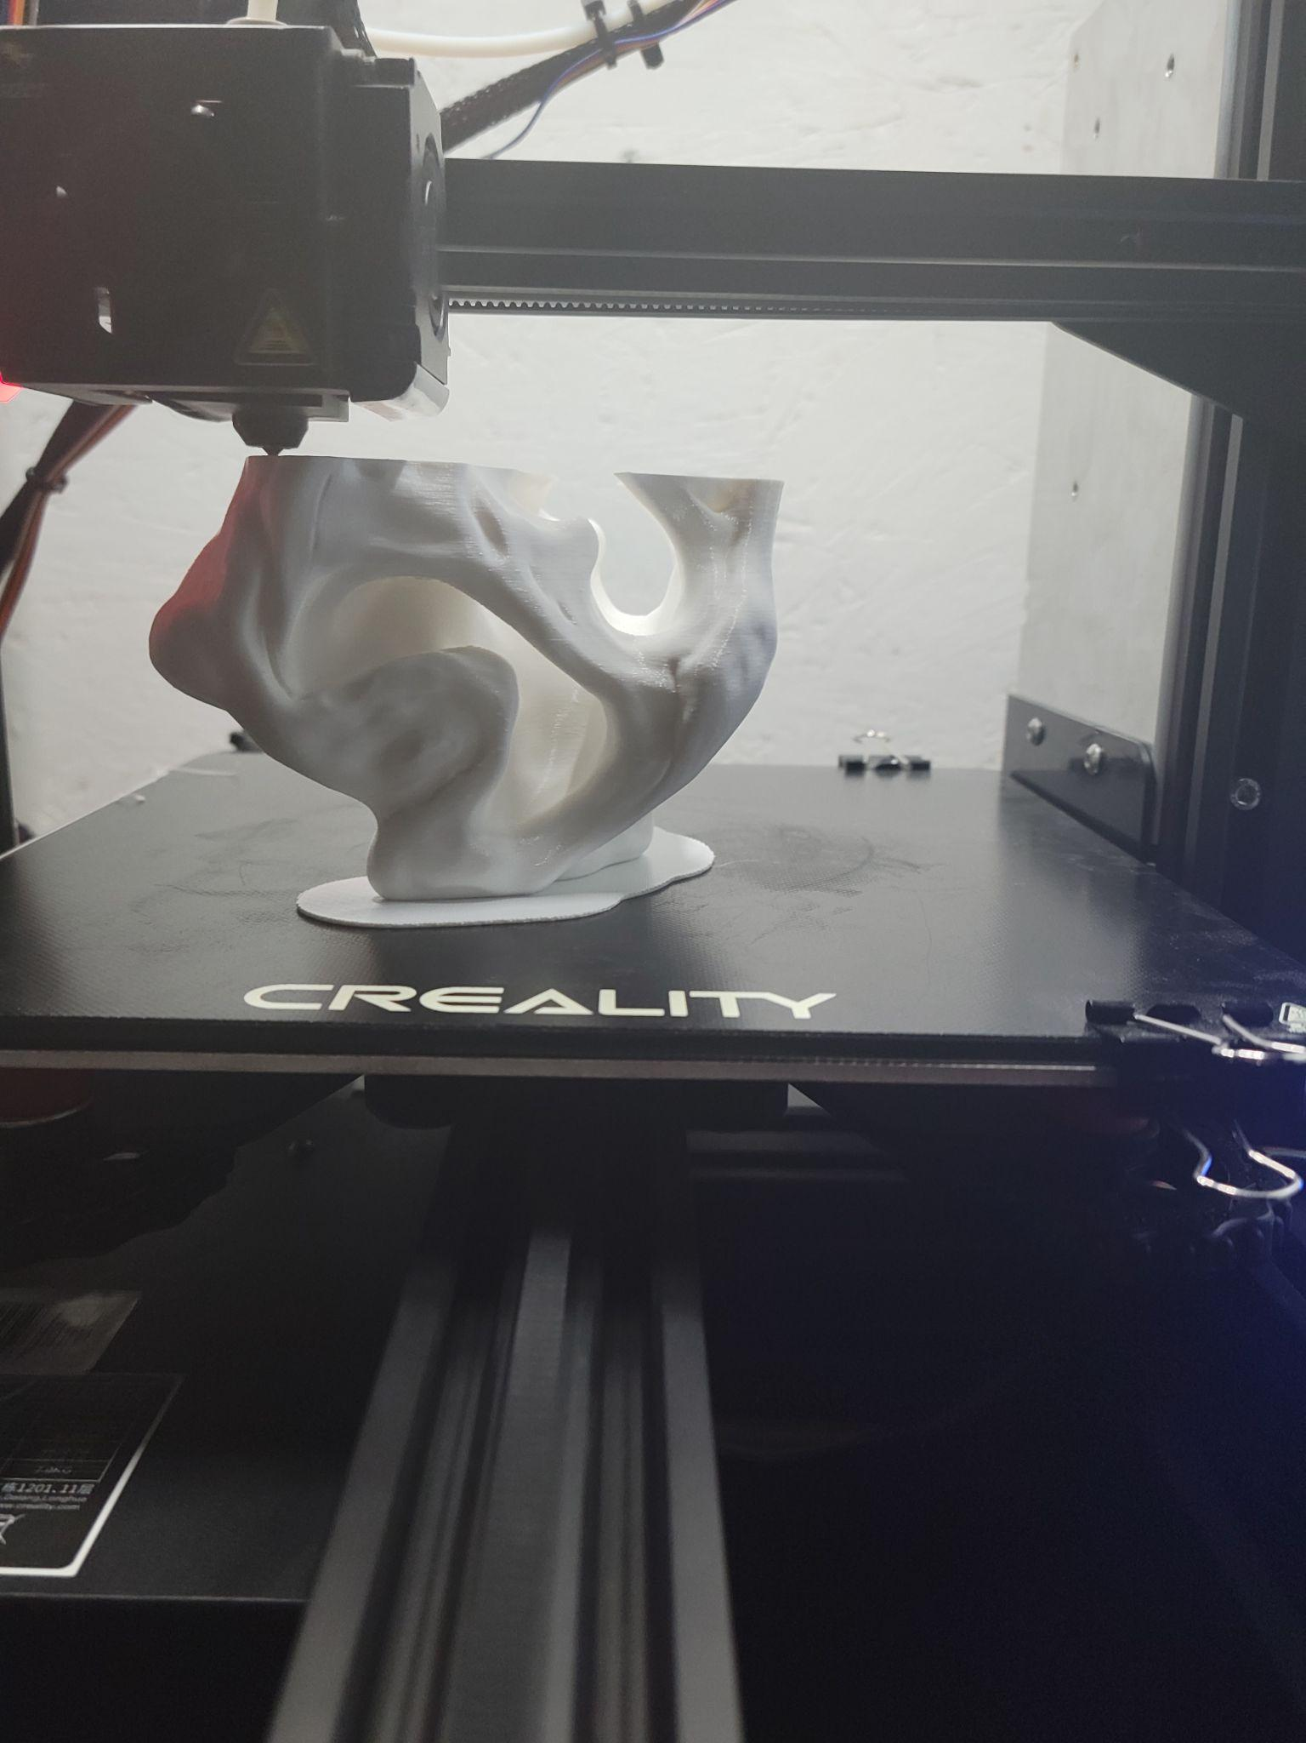

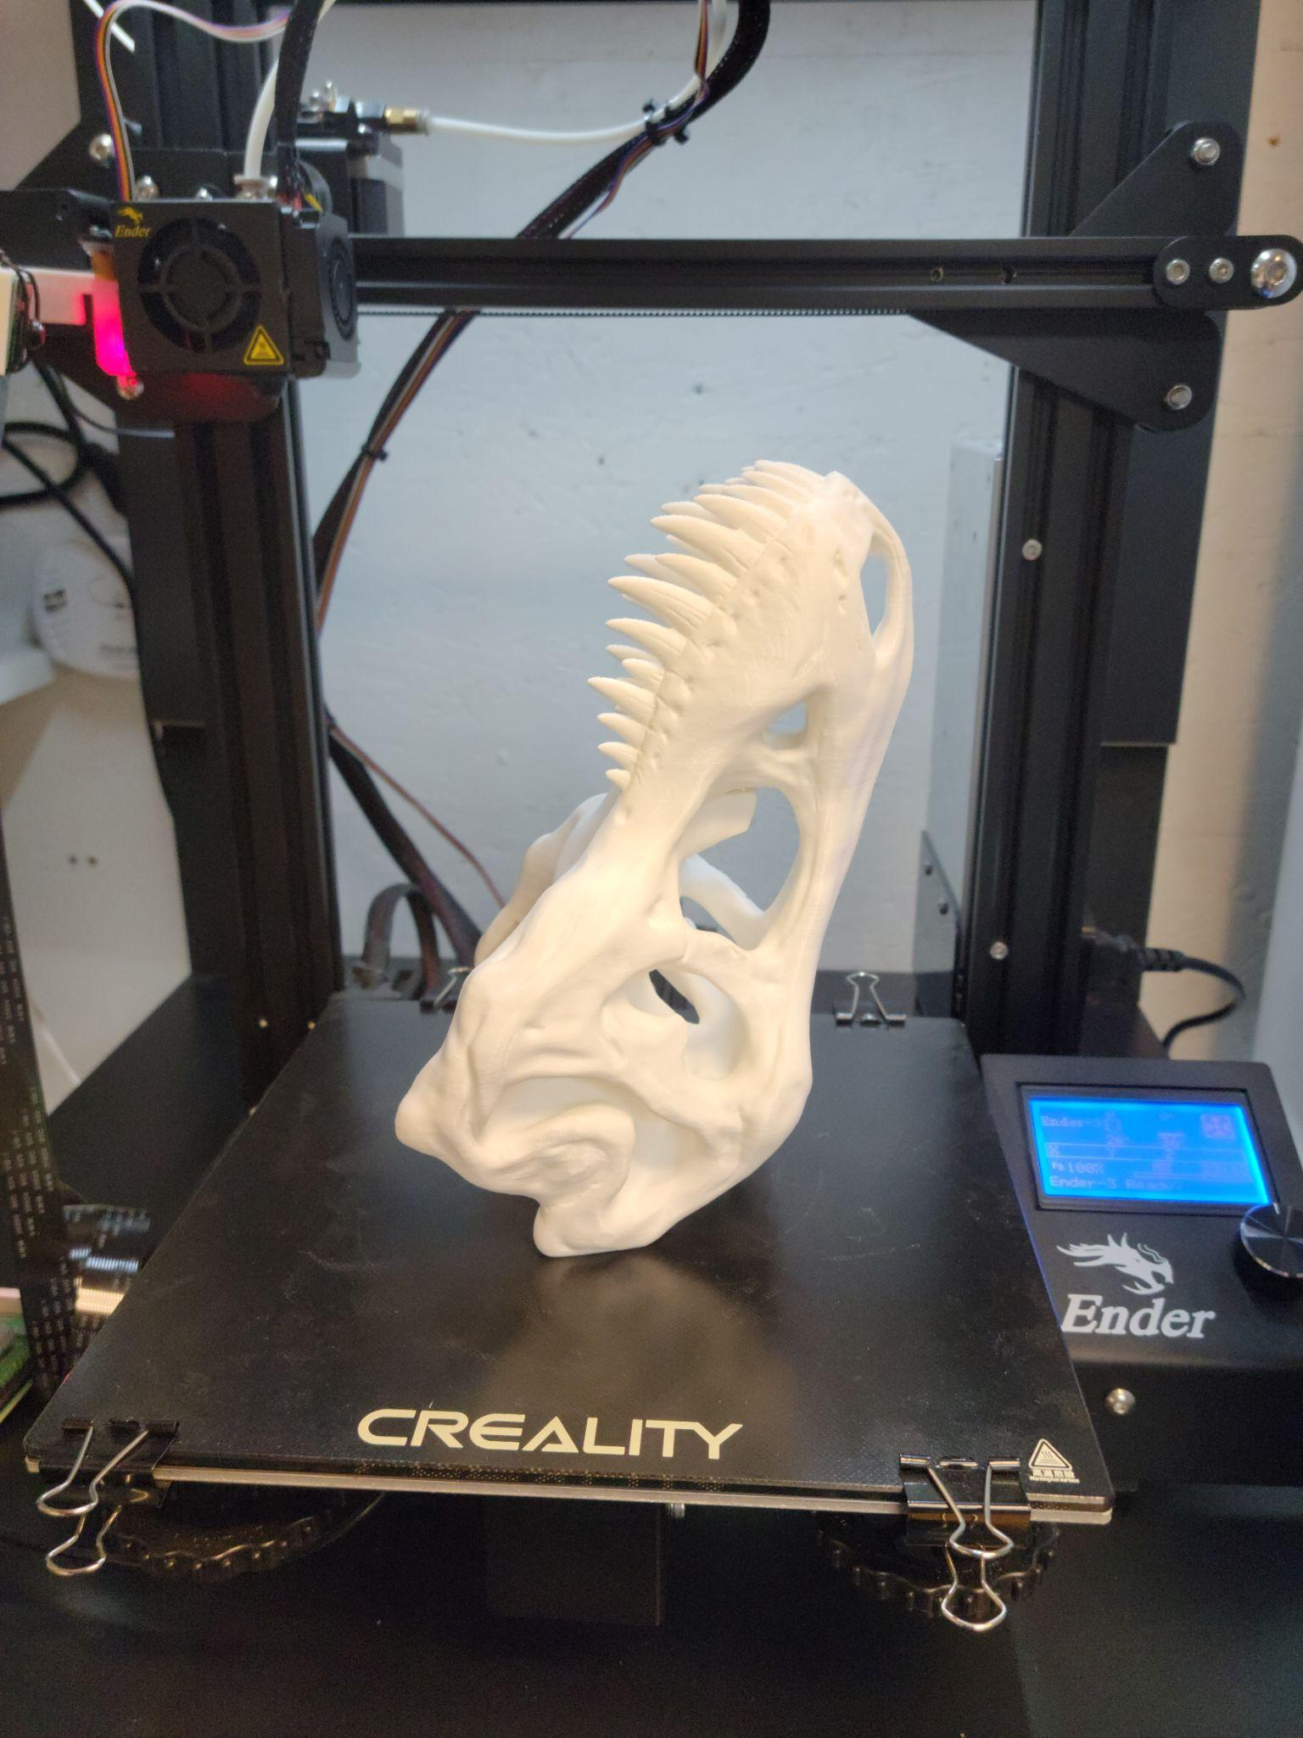
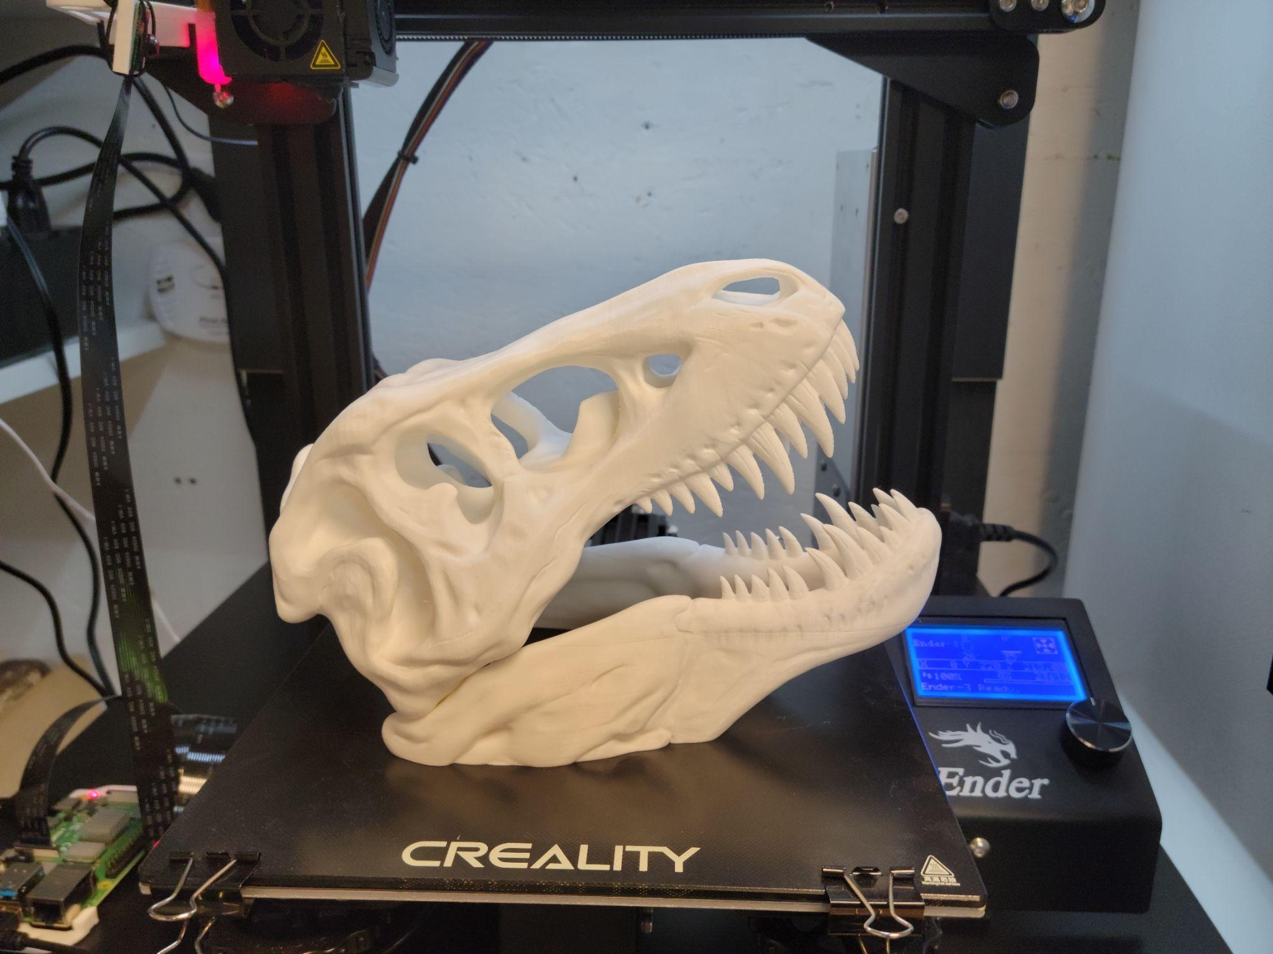

Skulls for UNH Production of She Kills Monsters
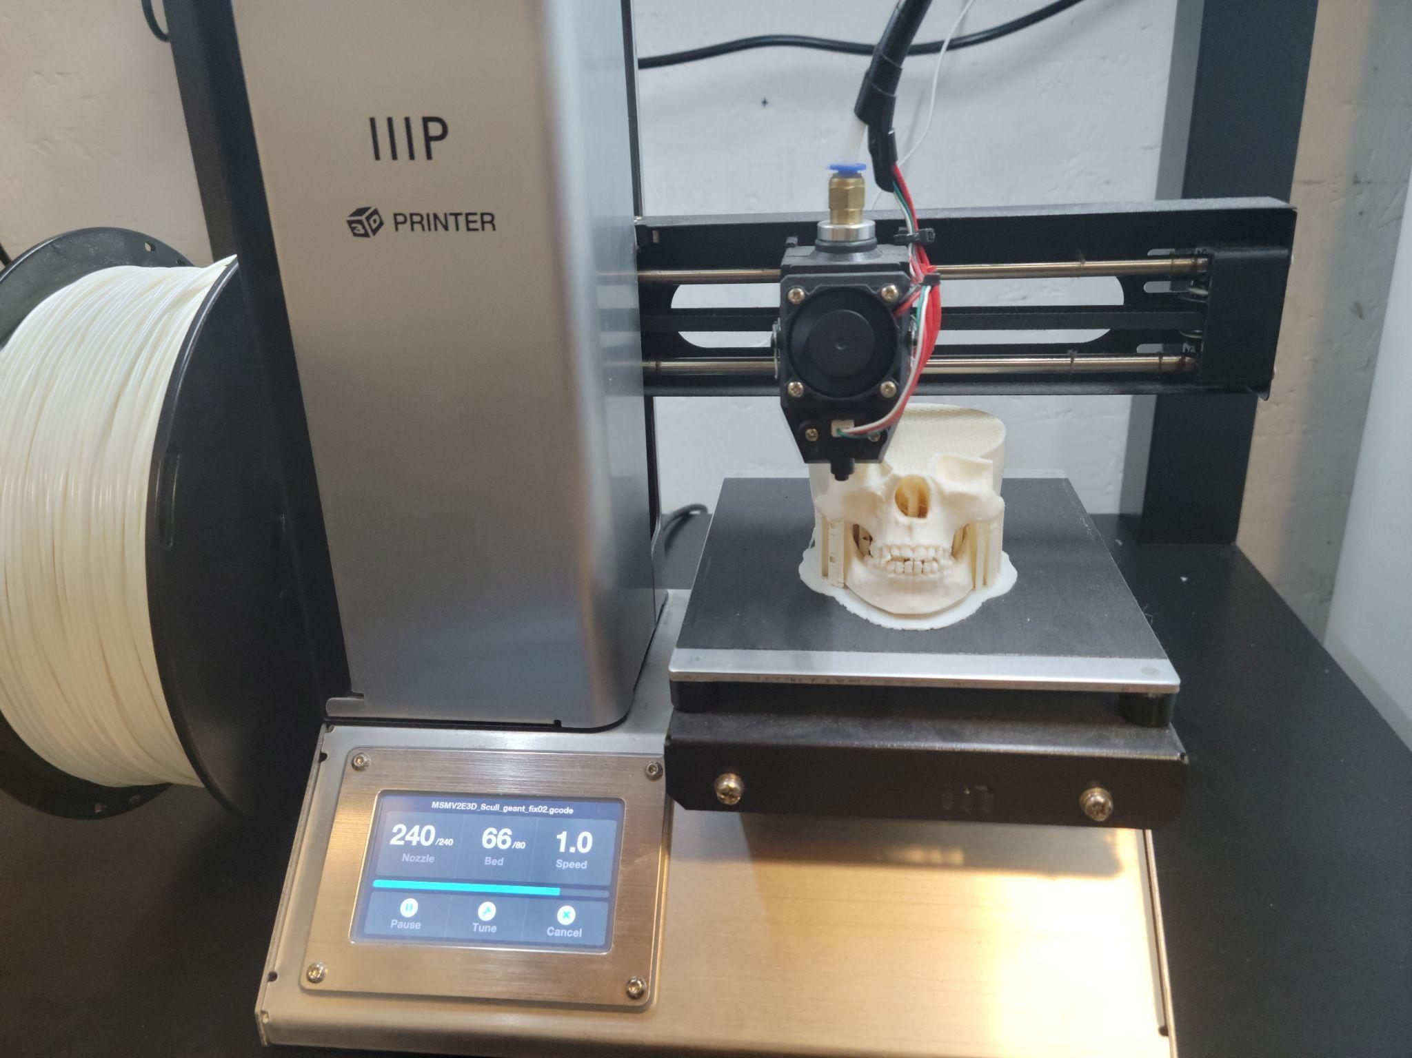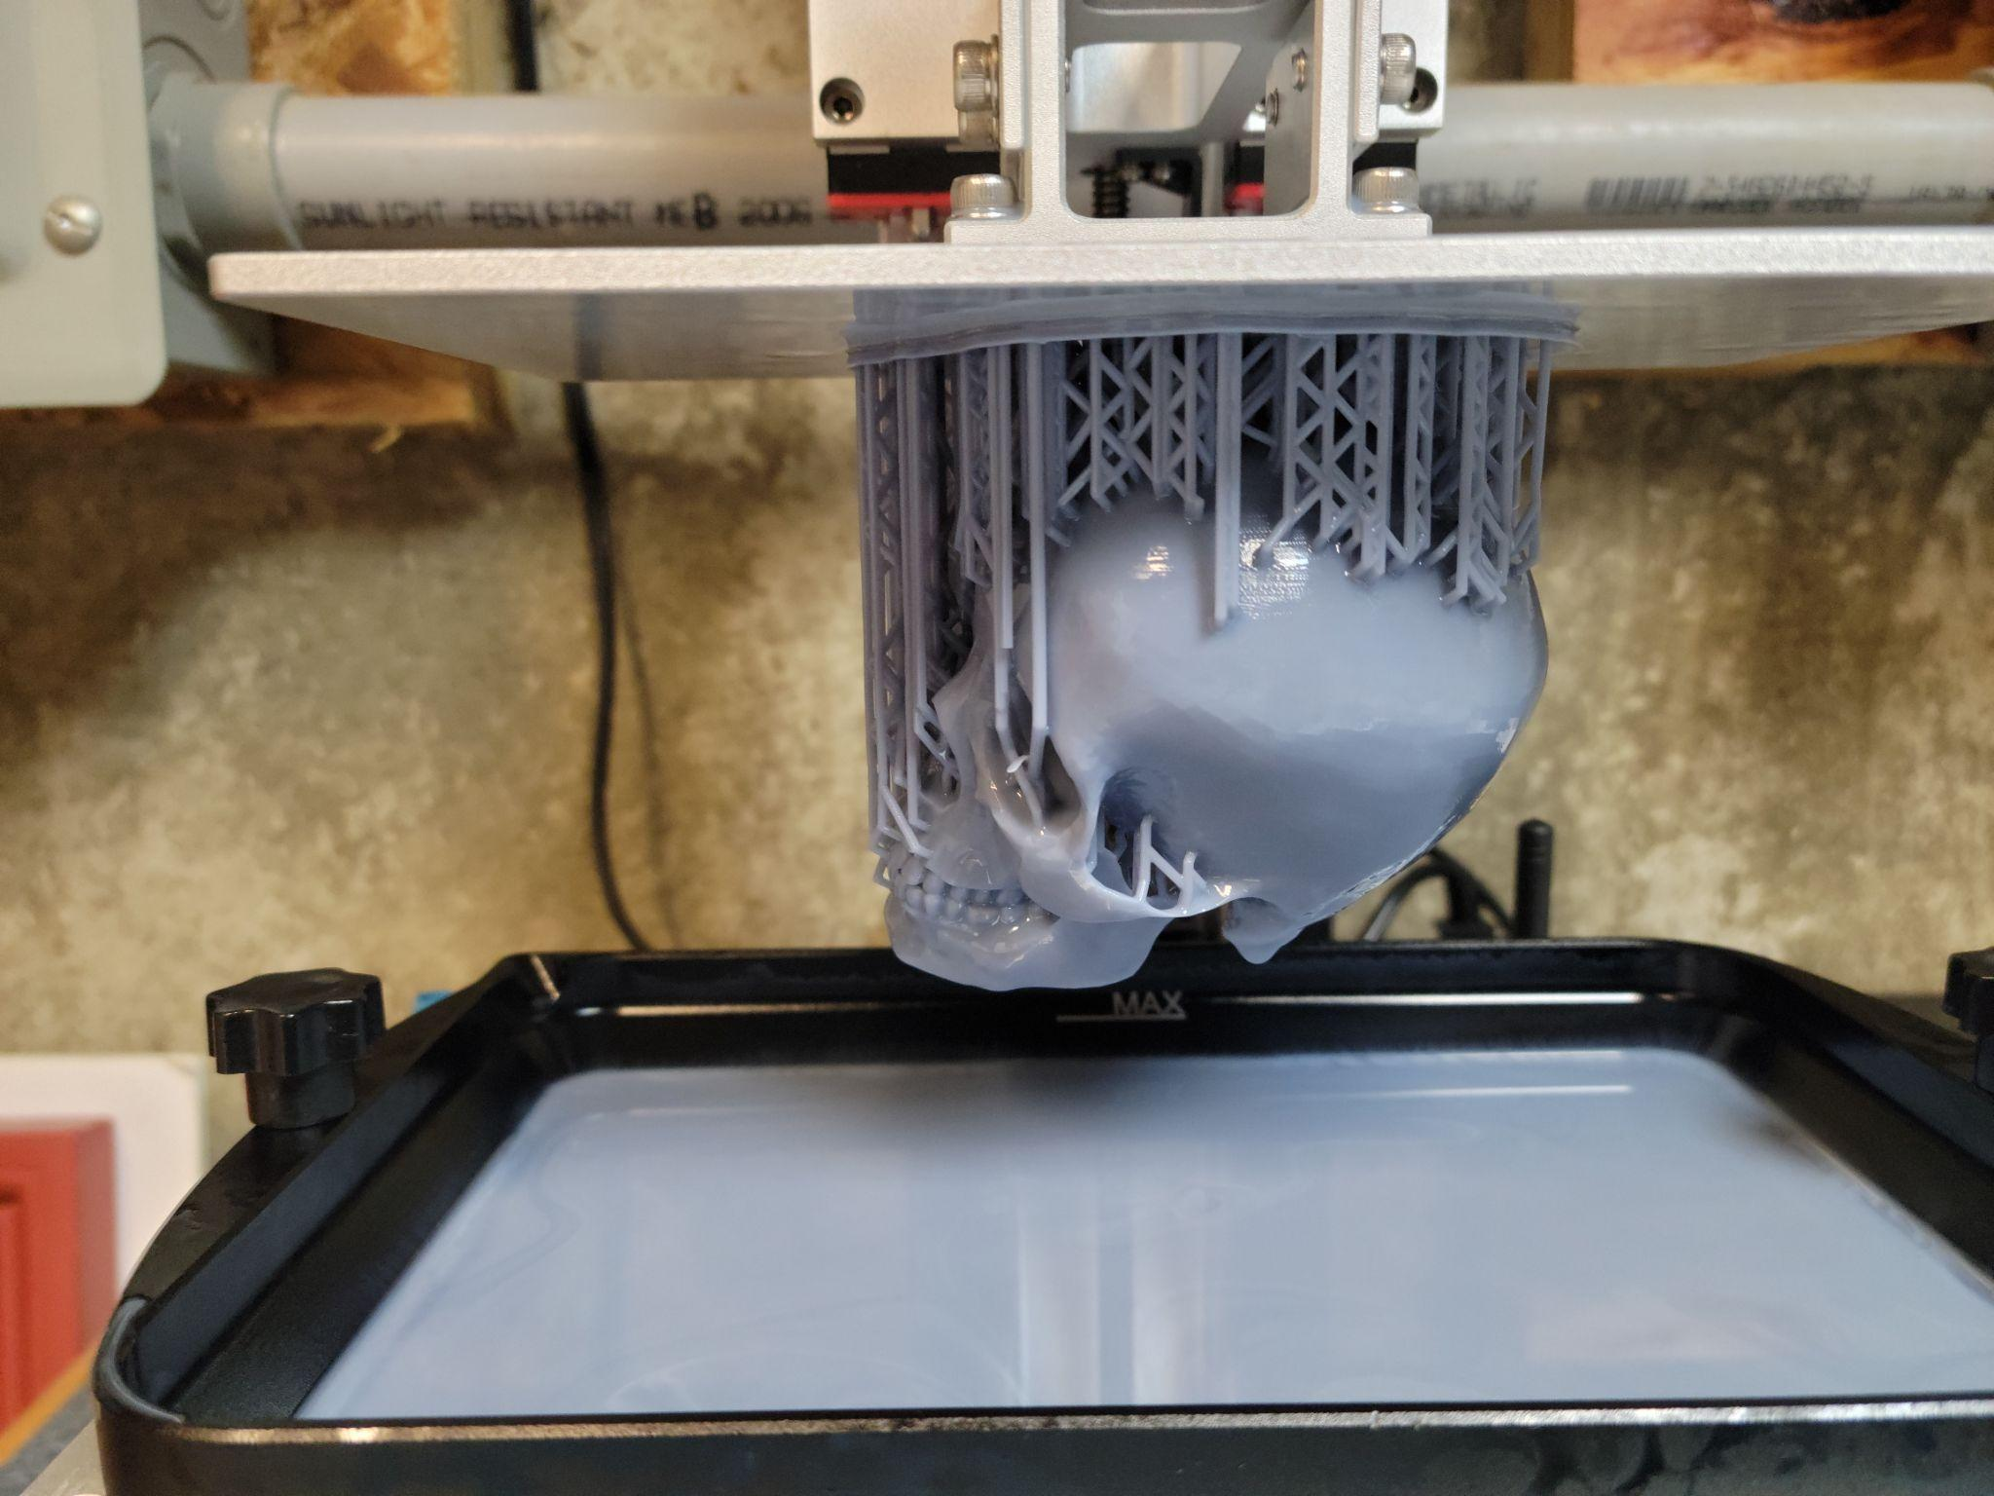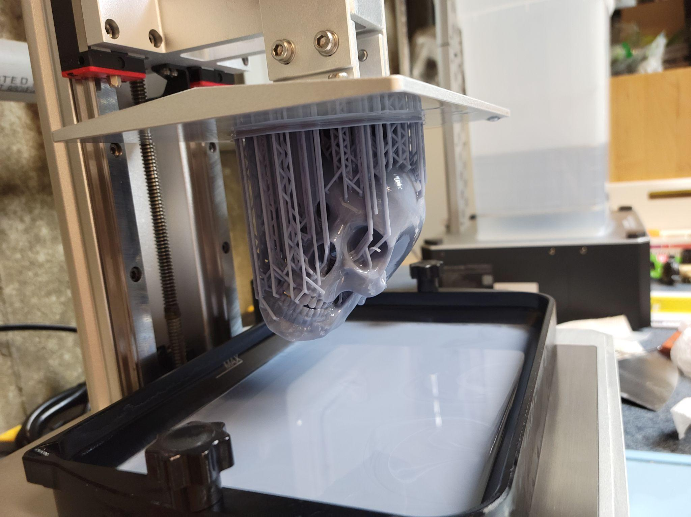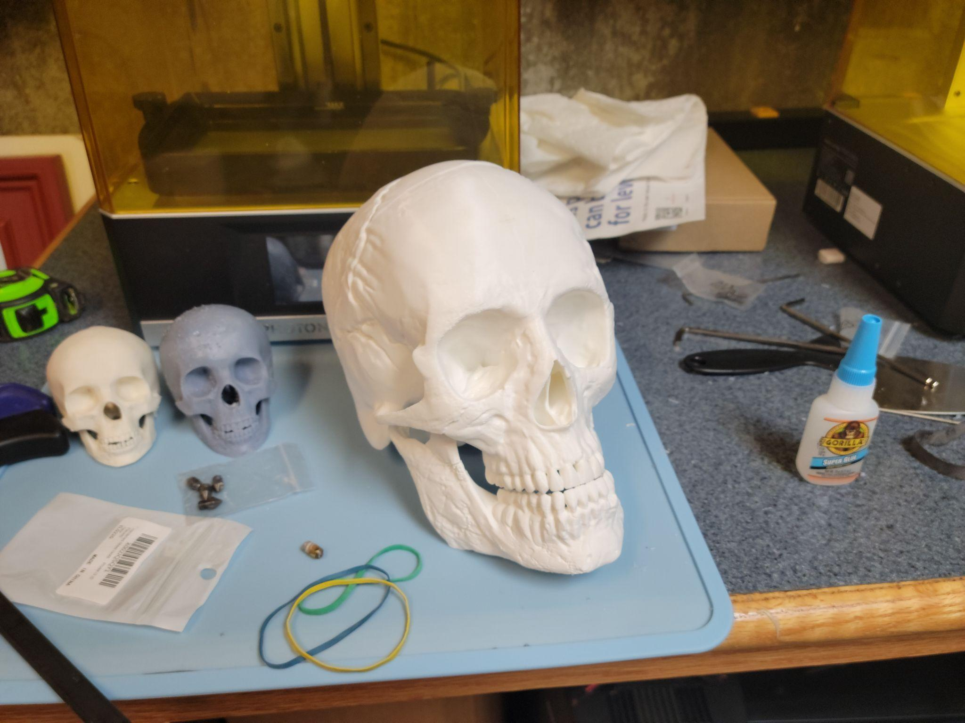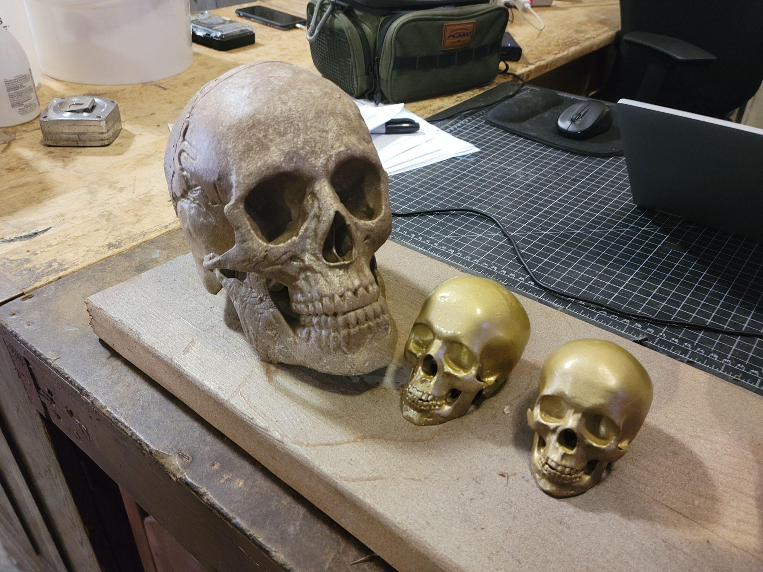

Failed Wood Print

3D Printed Set Models
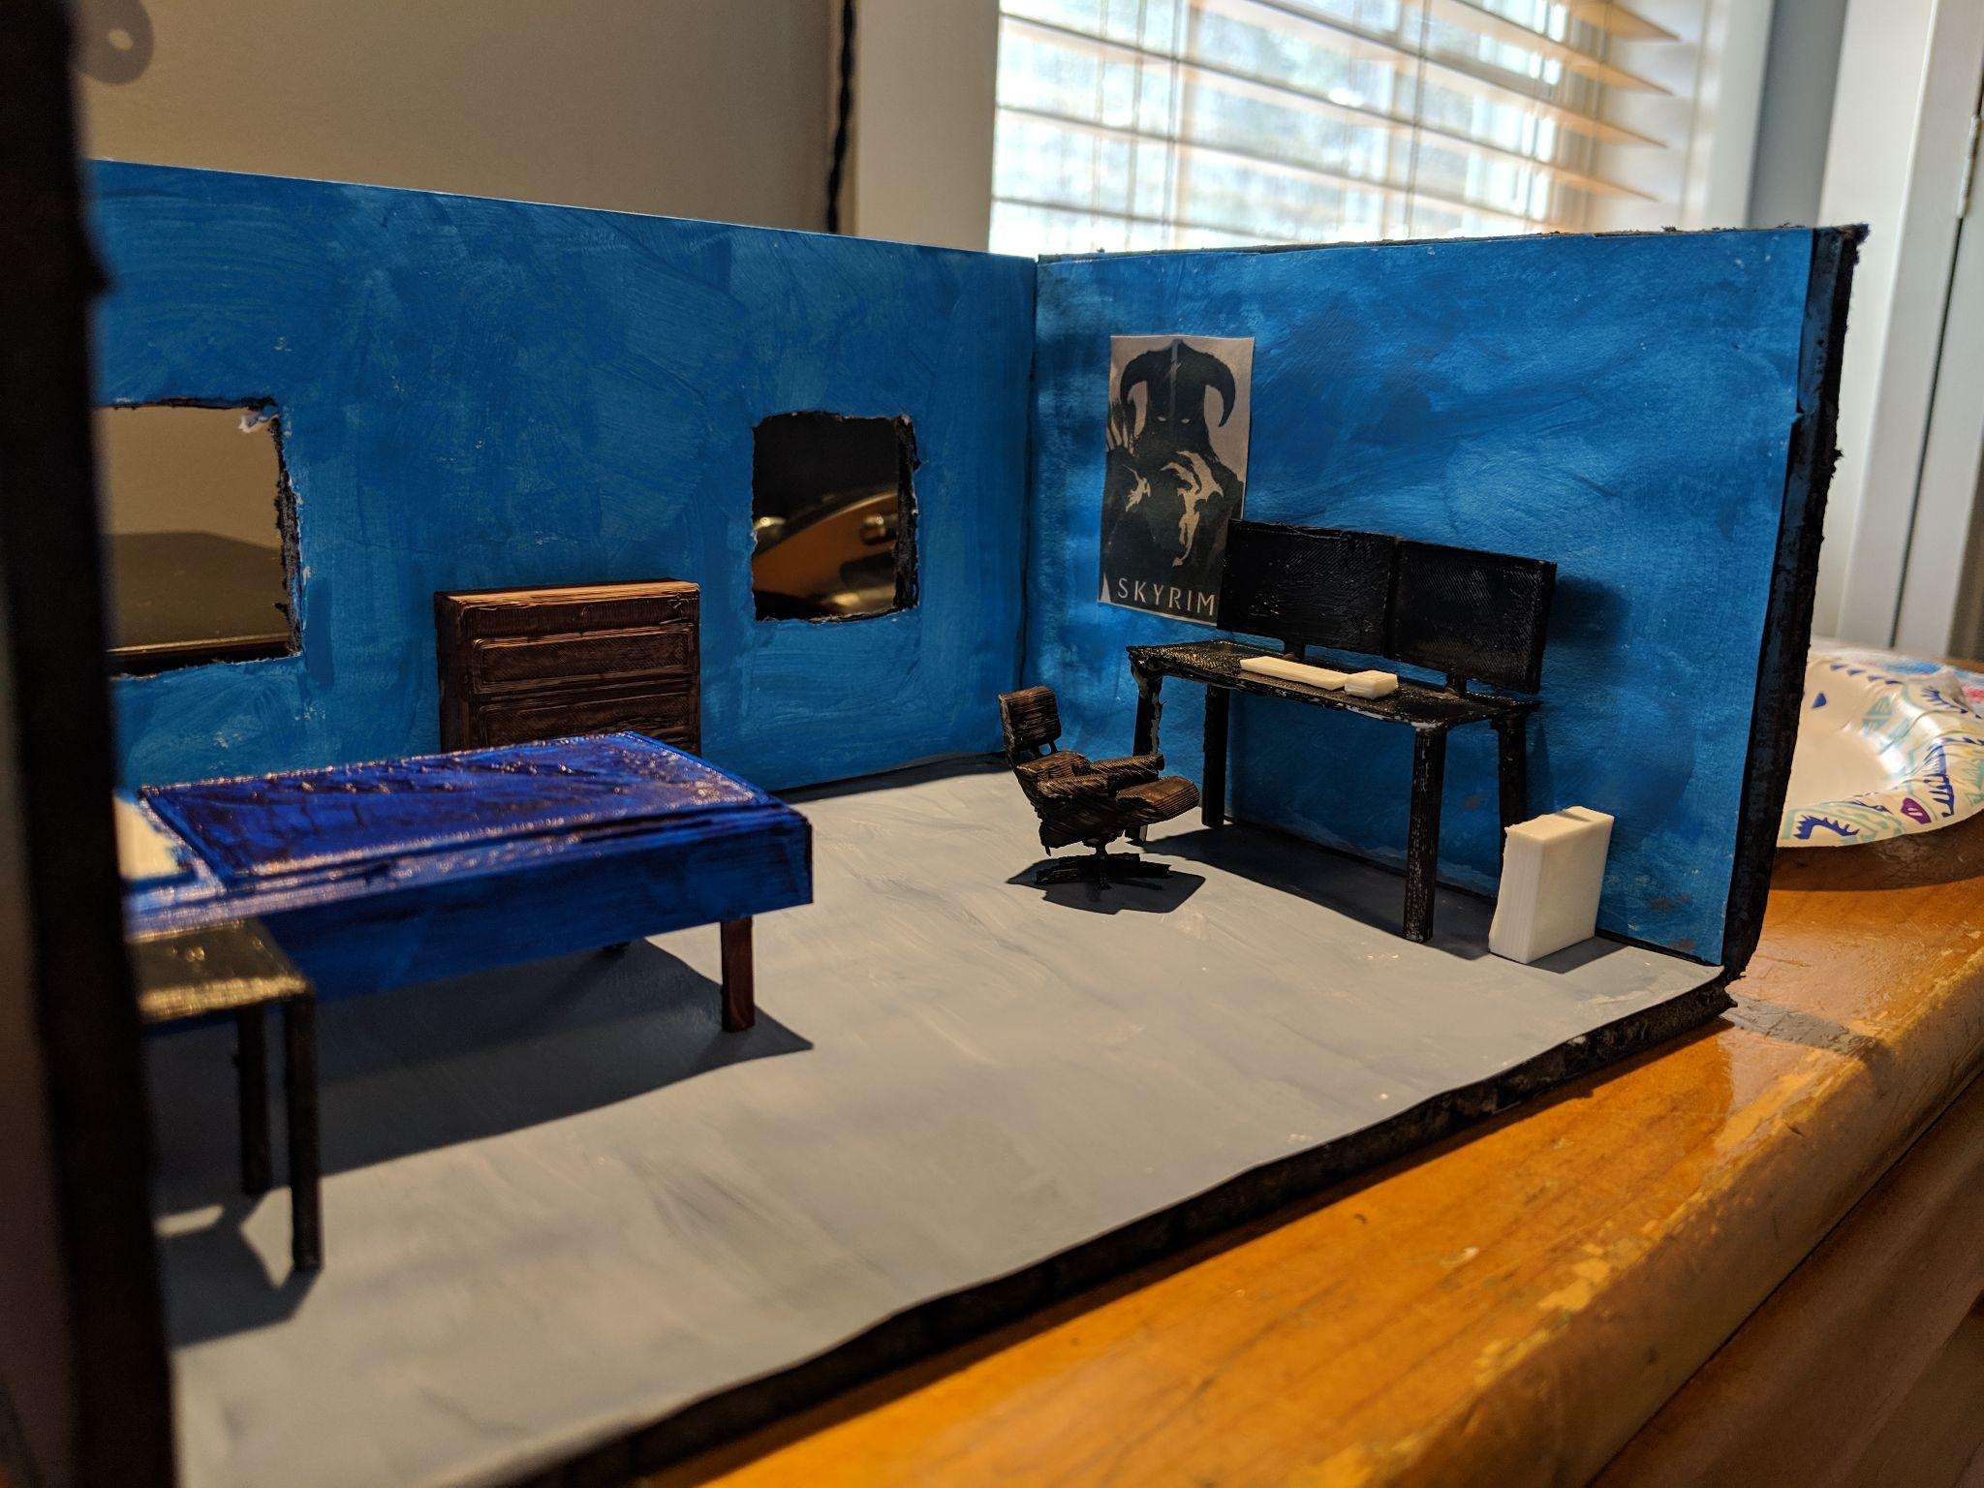

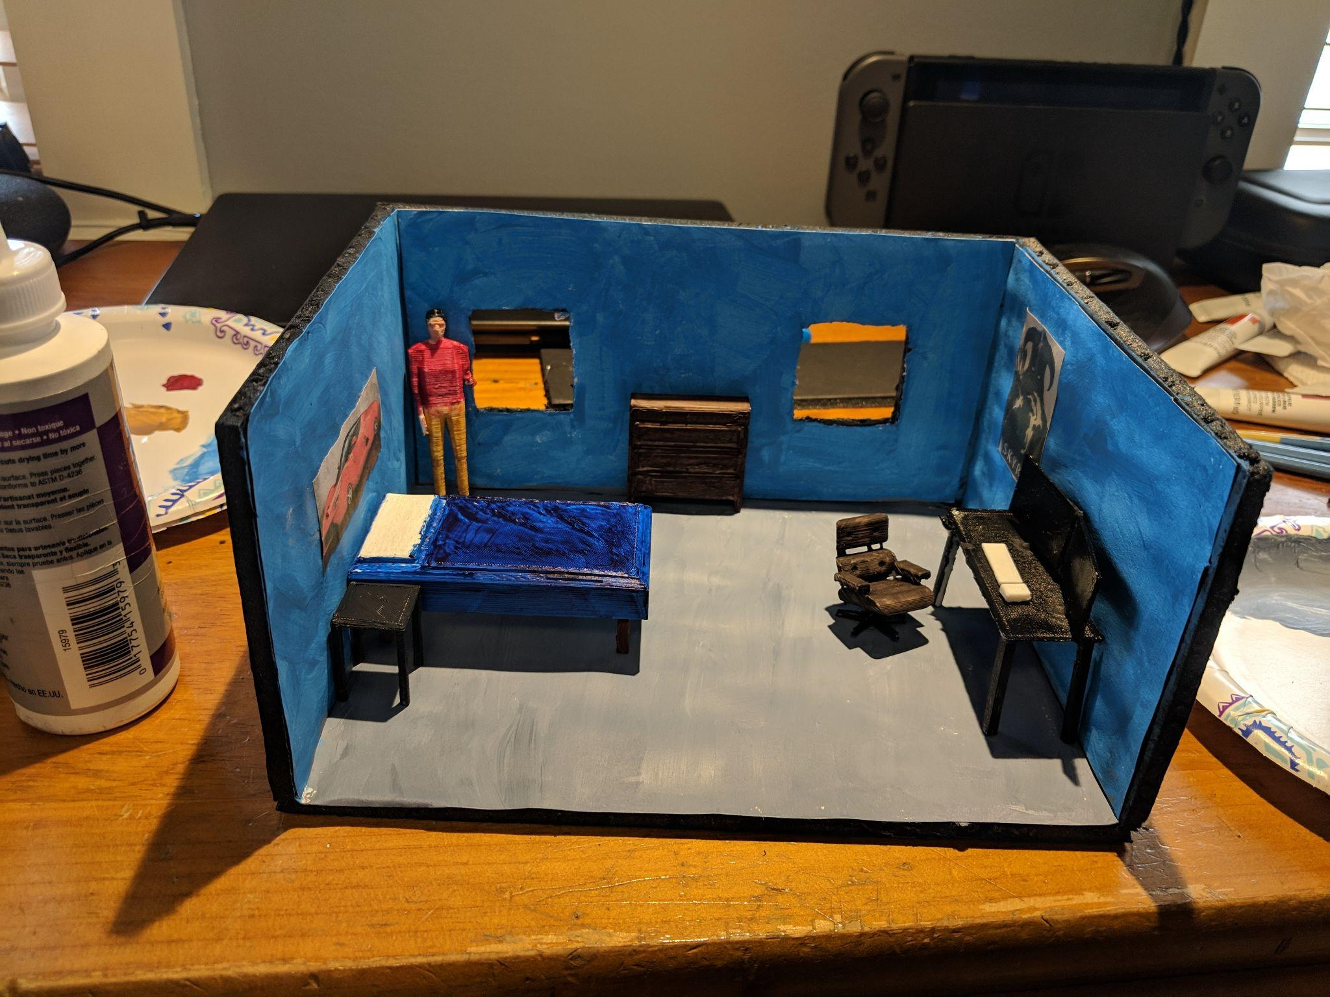

3D Hubs
Burkhart Dental

